**National University of Science and Technology**

**Faculty of Applied Sciences**

**Department of Computer Science**

**YEAR : FEBRUARY 2025**

***SMART HANGER SYSTEM***

|  |  |  |
| --- | --- | --- |
| 1. PROJECT MANAGER | MATONDO TAMUTSWA B. | N0238013E |
| 1. SYSTEM ARCHITECT | NYAPFUMBI TAKUNDA A. | N0231064X |
| 1. IoT ENGINEER | MUNINGWI DANIEL T.M | N0238701G |
| 1. DATA ANALYST | MBONGENI NDEBELE | N0239763D |
| 1. SOFTWARE ENGINEER | MUSHANDU NGUVAYASHE D. | N0234891W |
| 1. SOFTWARE ENGINEER | THALANAH BRANDON I. | N0231056Y |
| 1. TECHNICAL WRITER | MUNDA TAKUDZWA S. | N0232311N |
| 1. HARDWARE ENGINEER | CHAMISA KUDZAI | N0235145H |
| 1. QUALITY ASSUARANCE TESTER | MUSWERE CLAYTON | N0233570J |

GROUP 13…

### Abstract

The Smart Hanger System leverages IoT technology to transform retail inventory management and security. This system incorporates smart hangers with features such as rail locking mechanisms, RFID tags, and RGB light indicators to automate inventory tracking, prevent theft, and enhance the customer shopping experience. The system's design includes integration with Point of Sale (POS) systems, providing real-time inventory updates and valuable data analytics. An Agile development methodology and CASE tools are employed to ensure a structured and efficient development process. Questionnaires and forms are designed to gather user feedback and evaluate system performance. The system addresses key challenges in the retail sector, such as inventory shrinkage, inaccurate stock counts, and labor-intensive operations, by providing a solution that enhances security, improves inventory management, reduces labour costs, and ultimately increases customer satisfaction.

### Acknowledgements

The successful completion of the Smart Hanger System project and this accompanying document has been made possible by the dedicated efforts of a highly skilled team. We extend our sincere gratitude to the following individuals for their invaluable contributions:

MATONDO TAMUTSWA B., Project Manager, whose exceptional leadership and organizational skills were instrumental in guiding this project to fruition.

NYAPFUMBI TAKUNDA A., System Architect, for their expertise in designing the robust and scalable architecture of the Smart Hanger System.

MUNINGWI DANIEL T.M., IoT Engineer, whose technical proficiency in integrating IoT technologies was crucial to the system's functionality.

MBONGENI NDEBELE, Data Analyst, for their meticulous analysis of data, providing valuable insights for system optimization.

MUSHANDU NGUVAYASHE D., Software Engineer, and THALANAH BRANDON I., Software Engineer, for their skilled development of the system's software components.

MUNDA TAKUDZWA S., Technical Writer, for their diligence in documenting the project and ensuring clear communication.

CHAMISA KUDZAI, Hardware Engineer, for their expertise in designing and implementing the hardware components of the Smart Hanger System.

MUSWERE CLAYTON, Quality Assurance Tester, for their thorough testing and commitment to ensuring the system's reliability.

We also wish to express our heartfelt appreciation to our lecturer Mr Chilumani, whose guidance and mentorship played a pivotal role in shaping the research, design, and documentation of the Smart Hanger System. Their expertise and constructive feedback were invaluable throughout the entire process.

### Declaration

This document is a collaborative effort of the undersigned authors, with individual chapters developed under the supervision of our lecturer. We declare that this work is original and represents our collective understanding and design of the Smart Hanger System. We acknowledge the valuable input from retail shop owners, whose insights have contributed to the practical relevance of this project. This work has not been previously submitted for academic examination or publication.

Table of contents

i. Abstract 4

ii. Acknowledgements 4

iii. Declaration 5

iv. List of figures 10

Chapter 1: Introduction to the Smart Hanger System 10

1.1 Introduction 10

1.2 Background 11

1.2.1 Historical Context 11

1.2.2 Technological Advancements 11

1.2.3 Relevance to Zimbabwe 12

1.3 Problem Description 12

1.3.1 Inventory Shrinkage 12

1.3.2 Inaccurate Stock Counts 13

1.3.3 Labor-Intensive Operations 13

1.3.4 Customer Dissatisfaction 13

1.4 Aims 14

1.4.1 Enhance Inventory Management Through Real-Time Stock Tracking: 14

1.4.2 Strengthen Retail Security and Theft Prevention: 14

1.4.3 Improve Customer Shopping Experience and Satisfaction: 15

1.4.4 Optimize Retail Operations and Reduce Labor Costs: 15

1.4.5 Develop a Scalable and Cost-Effective Retail Solution: 16

1.4.6 Ensure Ethical and Sustainable Technology Implementation: 16

1.4.7 Conduct Testing, Evaluation, and Continuous Optimization: 17

1.5 Objectives 17

1.5.1 Design a Smart Hanger System: 17

1.5.2 Implement IoT Integration: 18

1.5.3 Develop Inventory Tracking Features: 18

1.5.4 Create a Product Location System: 19

1.5.5 Ensure Anti-Theft Functionality: 20

1.5.6 Design a User-Friendly Interface: 20

1.5.7 Test and Optimize the System: 21

1.5.8 Evaluate Cost and Feasibility 21

1.6 Ethical Considerations 22

1.6.1 Data Privacy and Security: 23

1.6.2 Transparency and Informed Consent: 23

1.6.3 Accessibility and Inclusivity 24

1.6.4 Workplace Ethics and Employee Impact: 24

1.6.5 Environmental Impact and Sustainability: 25

1.6.6 Ethical Use of AI and Automation: 25

1.6.7 Compliance with Legal and Retail Regulations: 25

1.7 Chapter Overview 26

Chapter 2: Literature review for the smart anger system 26

2.1 Introduction 26

2.2 Challenges faced in traditional inventory 27

2.3 Existing IoT-based solutions in retail 28

2.4 Technological framework for smart hanger systems 29

2.5 Stakeholders 30

2.6 Economic impact of IoT in retail 31

2.7 Future trends of IoT in retail 32

2.6 Security challenges in retail 33

2.7 Strategies and best practices for securing IoT devices 34

2.8 Integration with the POS system 36

2.9 Customer engagement technologies 36

2.10 Ethical and privacy consideration 37

2.11 Conclusion 38

CHAPTER 3: METHODOLOGY 39

3.1 Introduction 39

3.2 Research Methodology 40

3.2.1 Research Design 40

3.2.2 Data Collection Methods 41

3.2.3 Research Tools 42

3.2.4 Data Analysis 44

3.2.5 Ethical Considerations 45

3.3 Software Development Methodology 46

3.3.1 Development Approach 46

3.3.2 Phases of Development 48

3.3.3 Iterative Development 52

3.4 CASE Tools 53

3.4.1 Purpose of CASE Tools 53

3.4.2 List of Tools 54

3.4.3 Benefits of Using CASE Tools 57

3.5 Conclusion 58

Chapter 4: System Analysis and Design 59

*4.0* Introduction 59

4.1 Requirements evaluation 60

4.1.1 Functional requirements 60

4.1.2 Non Functional Requirements 61

4.1.3 Interface requirements 62

4.1.4 Performance requirements: 62

4.1.5 Security requirements 64

System Architecture 66

Use case diagram 72

4.3 Use cases 73

4.4 Use case description 74

Data Flow Diagram 75

4.5 Conclusion 79

Chapter 5: System Implementation and Testing 81

5.1 Introduction 81

5.2 User Interfaces 81

5.2.2 Smart Hanger Employee Portal 84

5.2.3 QR Code Generator 86

5.2.4 Point of Sale 88

5.3 Data Sources 89

5.3 Business Logic 91

5.3 Unit Testing 92

5.6 Integration Testing 95

5.7 Conclusion 98

Chapter 6: Conclusion and Future Directions 99

6.0 Introduction 99

6.1 Review of Objectives 99

6.2 Technical Review 100

6.3 Recommendations 101

6.4 Conclusion 102

6.5 Project Aims Revisited 103

6.6 Challenges and Lessons Learned 104

6.7 Future Directions 104

6.8 Final Reflections 105

Refrences : 106

Appendix 106

Questionnaire 106

Questionnaire for Retail Staff 106

Forms 110

A. For Retail Staff/Managers: 110

B. For Customers: 111

### List of figures

Figure 1: System architecture 65

Figure 2: flow chart 67

Figure 3: Use case diagram 72

Figure 4: level 0 DFD 74

Figure 5: level 1 DFD 76

Figure 6: login page 81

Figure 7: smart hanger employee portal 83

Figure 8: QR code generator 85

Figure 9: point of sale 87

Figure 10: Purchase trends 88

# Chapter 1: Introduction to the Smart Hanger System

## 1.1 Introduction

The integration of Internet of Things (IoT) technology is revolutionizing the retail industry by enhancing efficiency, security, and customer experience. The Smart Hanger System is an innovative solution designed to optimize inventory management and mitigate security risks in retail clothing stores. This system features IoT-enabled clothing hangers equipped with rail-locking mechanisms that communicate with Point of Sale (POS) systems, enabling real-time inventory tracking and automated theft prevention. Additionally, it incorporates smart indicators to display stock status, improving the shopping experience and stream lining store operations. By leveraging cutting-edge technology, the Smart Hanger System provides a robust solution to common retail challenges, ultimately increasing profitability and operational efficiency. This chapter provides an overview of the Smart Hanger System, outlining its background, problem description, objectives, significance, and ethical considerations.

## 1.2 Background

Retail operations in Zimbabwe, like in many developing economies, face persistent challenges in inventory management and loss prevention. Traditional stock-tracking methods rely on manual processes, which are labour-intensive, susceptible to human error, and inefficient. Retailers frequently contend with issues such as inventory shrinkage, inaccurate stock records, and poor customer service. The implementation of an IoT-driven Smart Hanger System presents a transformative opportunity to address these inefficiencies by automating and streamlining inventory control processes.

### 1.2.1 Historical Context

Historically, retail inventory management in Zimbabwe has depended on outdated, manual tracking methods. These systems have proven inadequate in handling the demands of a growing and competitive retail sector. As consumer expectations evolve, retailers require modern solutions to enhance accuracy, security, and efficiency. The adoption of IoT technology marks a significant step toward modernization, offering data-driven insights that facilitate more informed decision-making.

### 1.2.2 Technological Advancements

The proliferation of IoT has enabled the development of smart systems capable of monitoring and controlling various retail operations. By integrating sensors and communication modules into clothing hangers, the Smart Hanger System facilitates real-time inventory tracking and security enforcement. This technology not only enhances stock management but also improves customer experiences by providing instant product availability updates and streamlined search functionalities. The ability to automate inventory checks and track product movement ensures a more efficient supply chain and minimizes disruptions caused by stock inconsistencies.

### 1.2.3 Relevance to Zimbabwe

The retail sector is a critical component of Zimbabwe’s economy, contributing significantly to employment and GDP. However, challenges such as inventory shrinkage, inefficient stock tracking, and suboptimal customer service hinder business growth. The Smart Hanger System is particularly relevant in this context, as it provides a technologically advanced solution tailored to the specific needs of Zimbabwean retailers, enhancing competitiveness and operational efficiency. By implementing this system, retailers can reduce theft, optimize resource allocation, and elevate the shopping experience to meet international standards.

## 1.3 Problem Description

Zimbabwean retailers face several challenges that adversely impact operational efficiency and profitability. The Smart Hanger System is designed to address these issues by providing targeted technological solutions.

### 1.3.1 Inventory Shrinkage

Theft, shoplifting, and administrative errors contribute to significant financial losses. The Smart Hanger System mitigates these risks through a rail-locking mechanism that restricts unauthorized removal of items. The locking system is integrated with the POS system, ensuring that hangers can only be released upon valid purchase authorization. This provides an effective deterrent against theft while allowing store employees to focus on other aspects of customer service.

### 1.3.2 Inaccurate Stock Counts

Manual stock-tracking methods often lead to discrepancies between recorded and actual inventory levels, complicating stock replenishment and decision-making. The Smart Hanger System addresses this issue by incorporating RFID tags or barcodes, allowing for real-time inventory updates and accurate stock monitoring. This minimizes errors, ensures a steady supply of popular products, and reduces instances of overstocking or understocking.

### 1.3.3 Labor-Intensive Operations

Traditional inventory management relies heavily on manual labor, increasing operational costs and inefficiencies. By implementing an automated inventory tracking system, the Smart Hanger System reduces the need for labor-intensive stocktaking, freeing up staff to focus on customer service and other value-added activities. This not only leads to cost savings but also enhances employee productivity and job satisfaction.

### 1.3.4 Customer Dissatisfaction

A lack of real-time stock visibility often results in customer frustration due to inaccurate product availability information. The Smart Hanger System enhances customer experience by integrating RGB light indicators to display stock status in real-time and allowing customers to search for items via a mobile web application. The system also enables product location assistance by triggering hanger-based indicators when a product is searched for, significantly reducing shopping time and improving customer satisfaction.

## 1.4 Aims

The primary aim of this project is to develop and implement a **Smart Hanger System** that leverages **IoT technology, security mechanisms, and smart indicators** to enhance retail inventory management, improve customer experience, and optimize store operations. This system is designed to address challenges such as inventory shrinkage, inaccurate stock tracking, inefficient labour use, and customer dissatisfaction.

To achieve this overarching goal, the project focuses on the following key aims:

### 1.4.1 Enhance Inventory Management Through Real-Time Stock Tracking:

Traditional inventory tracking methods in retail stores rely on manual stocktaking, which is prone to human error and inefficiencies. The Smart Hanger System will:

* Integrate **RFID tags or barcodes** with IoT technology to facilitate **real-time inventory tracking** and stock updates.
* Automatically **synchronize inventory levels** with a centralized database to eliminate discrepancies and ensure accurate stock monitoring.
* Provide **automated low-stock alerts** to enable timely replenishment, reducing instances of understocking or overstocking.

### 1.4.2 Strengthen Retail Security and Theft Prevention:

Retailers face significant financial losses due to **inventory shrinkage caused by theft, shoplifting, and administrative errors**. To address this, the system will:

* Implement **a rail-locking mechanism** that prevents unauthorized removal of clothing items from hangers.
* Ensure hangers can only be **unlocked upon a verified transaction** via the POS system or mobile application.
* Provide **an additional layer of security** by sending real-time alerts to store managers in case of unauthorized tampering or forceful removal of items.

### 1.4.3 Improve Customer Shopping Experience and Satisfaction:

Customers often face difficulties in locating specific products or determining stock availability, leading to frustration and lost sales. The Smart Hanger System will:

* Integrate **RGB light indicators** that visually communicate stock availability (e.g., **green for available, orange for low stock, and red for out of stock**).
* Enable **a product search functionality via a mobile web application**, allowing customers to locate items quickly.
* Activate **RGB indicators on the searched item’s hanger**, guiding customers directly to the product’s location within the store.
* Reduce shopping time and enhance overall **customer convenience and satisfaction**.

### 1.4.4 Optimize Retail Operations and Reduce Labor Costs:

Retailers often spend excessive time and resources on manual stock management, increasing operational costs and reducing staff efficiency. The Smart Hanger System will:

* **Automate stock monitoring and updates**, minimizing the need for labour-intensive stocktaking processes.
* Enable **store employees to focus on customer service and sales** rather than routine inventory checks.
* Improve overall **operational efficiency** by streamlining inventory processes, allowing businesses to reallocate resources more effectively.

### 1.4.5 Develop a Scalable and Cost-Effective Retail Solution:

The Smart Hanger System should be practical and financially viable for retailers of different sizes, particularly in Zimbabwe’s developing retail sector. To achieve this, the system will:

* Utilize **cost-effective yet durable materials and IoT components** to ensure affordability for small and medium-sized businesses.
* Be designed for **easy installation and maintenance**, reducing operational overhead costs.
* Support **scalability**, allowing retailers to expand their Smart Hanger implementation as needed without significant infrastructure changes.

### 1.4.6 Ensure Ethical and Sustainable Technology Implementation:

The development and deployment of the Smart Hanger System must align with ethical principles and sustainability goals. This includes:

* **Protecting customer and inventory data** through secure encryption and compliance with data privacy regulations.
* Designing the system to be **user-friendly and accessible** to both customers and retail staff, regardless of technical expertise.
* **Minimizing environmental impact** by using energy-efficient IoT components and sustainable materials for hangers.

### 1.4.7 Conduct Testing, Evaluation, and Continuous Optimization:

To ensure reliability and effectiveness, the system will undergo **rigorous testing and optimization** before full deployment. This involves:

* Conducting **pilot testing** in a retail store environment to evaluate functionality and performance.
* Gathering **user feedback** from store employees and customers to refine the system’s usability.
* **Optimizing system performance** for accuracy, security, and real-time responsiveness

## 1.5 Objectives

To achieve the aims of the **Smart Hanger System**, this project sets out the following specific objectives:

### 1.5.1 Design a Smart Hanger System:

Develop an innovative hanger with integrated security and inventory management features to enhance retail operations. This includes:

* **Rail-Locking Mechanism:**
  + Implement an automated **locking system** that prevents unauthorized removal of hangers from the clothing rail.
  + Ensure the lock can only be released upon **successful purchase authorization** through a POS system or mobile app.
  + Develop a failsafe unlocking method in case of system malfunctions.
* **RGB Light Indicators for Stock Status:**
  + Integrate **LED indicators** to provide real-time visual feedback on stock levels:
    - **Green:** Item is available.
    - **Red:** Low/Out of stock.
  + Ensure the indicators are **energy-efficient** and visible even in well-lit retail environments.

### 1.5.2 Implement IoT Integration:

Enable seamless communication between the Smart Hanger System and a centralized inventory management platform by:

* **Selecting an appropriate IoT communication protocol** (e.g., Wi-Fi, Bluetooth Low Energy) for efficient data transfer.
* **Developing a cloud-based or on-premises database** to store real-time stock information.
* **Ensuring real-time synchronization** between the hangers, the inventory system, and the POS system.
* **Incorporating an alert system** to notify store staff of potential stock issues or unauthorized access attempts.

### 1.5.3 Develop Inventory Tracking Features:

Enhance inventory accuracy by automating stock monitoring and minimizing human errors through:

* **RFID or Barcode Integration:**
  + Equip each hanger with **RFID tags** or **barcode labels** for real-time tracking.
  + Ensure compatibility with **existing POS systems** for easy implementation.
* **Automated Stock Level Adjustments:**
  + Update stock levels automatically when an item is sold, restocked, or removed.
  + Enable **predictive analytics** for demand forecasting based on sales trends.
* **Theft Detection and Alerts:**
  + Implement **motion sensors** that detect unusual hanger activity.
  + Generate alerts when an unauthorized hanger removal attempt occurs.

### 1.5.4 Create a Product Location System:

Enhance customer convenience by enabling easy product search and location assistance through:

* **Mobile Web Application:**
  + Develop a user-friendly **mobile application or web-based interface** that allows customers to search for specific clothing items.
  + Display product details, including **size availability and location within the store**.
* **Smart Hanger-Based Product Indicators:**
  + When a customer searches for a product, the corresponding hanger’s **RGB indicator should flash**, guiding them to the item.
  + Ensure seamless integration with **in-store kiosks or mobile apps** for product lookup.

### 1.5.5 Ensure Anti-Theft Functionality:

Enhance security and loss prevention by implementing:

* **POS-Linked Security Mechanism:**
  + Hangers should remain locked on the rail until a **successful transaction** is recorded at the POS system.
  + Ensure that authorized store personnel can manually override the lock in case of system failures.
* **Tamper-Detection System:**
  + Develop a feature that **triggers an alert** if someone attempts to remove an item forcefully.
  + Integrate an **alarm system** that notifies security staff of suspicious activity.

### 1.5.6 Design a User-Friendly Interface:

Ensure that both customers and retail staff can interact efficiently with the system by:

* **Developing an Intuitive Mobile Web Application:**
  + Allow customers to **browse stock availability** remotely or in-store.
  + Enable QR code scanning for instant item details.
* **Providing Retail Staff with an Inventory Dashboard:**
  + Offer real-time inventory monitoring and **low-stock alerts**.
  + Allow easy restocking and system diagnostics through a **tablet or computer interface**.
* **Ensuring Accessibility:**
  + Make the interface **multilingual** and easy to navigate for non-technical users.
  + Integrate **voice command and screen reader compatibility** for visually impaired users.

### 1.5.7 Test and Optimize the System:

Ensure system reliability, usability, and scalability by:

* **Conducting Usability Testing:**
  + Run test cases with **retail employees and customers** to assess ease of use.
  + Gather feedback to refine the system’s interface and functionality.
* **Optimizing Performance:**
  + Improve **response time** for real-time stock updates and hanger interactions.
  + Ensure the system is **scalable** for different store sizes, from small boutiques to large department stores.
  + Conduct **stress testing** to measure performance under peak load conditions.
* **Ensuring Energy Efficiency:**
  + Optimize power consumption to allow battery-powered hangers to last for extended periods.
  + Integrate **sleep mode features** when hangers are not in use.

1.5.8 Evaluate Cost and Feasibility**:**

Ensure that the Smart Hanger System is financially viable and practical for implementation by:

* **Assessing Material and Component Costs:**
  + Use cost-effective **IoT sensors, RFID chips, and microcontrollers** without compromising durability.
  + Compare costs with traditional security and inventory management solutions.
* **Simplifying Installation and Maintenance:**
  + Design a **modular system** that allows for easy replacement of individual components.
  + Minimize the need for **frequent technical maintenance** to reduce long-term costs.
* **Considering Affordability for Small and Medium Retailers:**
  + Develop a pricing model that makes the system accessible to **Zimbabwean businesses** while ensuring profitability.
  + Offer **tiered features** to accommodate different business needs (e.g., small stores vs. large chain retailers).

## 1.6 Ethical Considerations

The implementation of the Smart Hanger System introduces several ethical considerations that must be addressed to ensure fairness, privacy, transparency, and sustainability. The following aspects outline key ethical concerns and mitigation strategies:

### 1.6.1 Data Privacy and Security:

The Smart Hanger System relies on IoT technology to collect and transmit inventory and customer interaction data. As with any data-driven system, ensuring data privacy and security is crucial to prevent unauthorized access, breaches, or misuse of information.

* Customer and Retailer Data Protection: The system should adhere to data protection regulations such as the General Data Protection Regulation (GDPR) or any relevant local laws. Personal data collected through mobile applications (e.g., search history, purchase behavior) must be anonymized or encrypted.
* Secure Communication Channels: Data transmission between the Smart Hanger System, POS system, and mobile web application must be encrypted using secure protocols (e.g., TLS/SSL) to prevent cyberattacks.
* Access Control: Only authorized personnel should have access to sensitive inventory and sales data. Implementing role-based access control (RBAC) can help mitigate risks.

### 1.6.2 Transparency and Informed Consent:

Retailers and customers should be fully informed about how the Smart Hanger System operates and how their data is being used. Ethical transparency ensures that all stakeholders understand the system’s functionalities and limitations.

* Customer Awareness: Retail stores implementing the Smart Hanger System should display clear notices informing customers about the use of IoT-enabled hangers, tracking mechanisms, and any associated mobile applications.
* Informed Consent: If the system collects customer interaction data (e.g., item searches via a mobile app), users should be given the option to opt-in or opt-out of data collection and tracking features.

1.6.3 Accessibility and Inclusivity**:**

The system should be designed to accommodate all retail employees and customers, including individuals with disabilities or limited technical skills. Ethical design principles prioritize equal access and usability.

* User-Friendly Interfaces: The mobile web application and inventory dashboard should be intuitive and easy to use, even for employees with minimal technical expertise.
* Assistive Features: Consider incorporating accessibility options such as voice commands, screen reader compatibility, and adjustable text sizes for visually impaired users.
* Language and Localization: The system should support multiple languages to cater to diverse customer demographics, particularly in multilingual regions like Zimbabwe.

### 1.6.4 Workplace Ethics and Employee Impact:

Automation in retail should be implemented in a way that enhances efficiency without leading to unfair job displacement or exploitation of workers.

* Job Security and Role Adaptation: While automation reduces the need for manual stock checks, employees should be trained for new roles such as customer service enhancement, system monitoring, and data analysis rather than being displaced.
* Fair Labor Practices: Ethical implementation ensures that automation supplements human labour rather than replacing it entirely. Employees should also be provided with opportunities for skill development to adapt to the new system.

### 1.6.5 Environmental Impact and Sustainability:

The production, use, and disposal of IoT-enabled hangers must be environmentally responsible to minimize electronic waste and carbon footprints.

* Sustainable Materials: Hangers should be designed using recyclable or biodegradable materials to reduce plastic waste in retail.
* Energy Efficiency: The system should use low-power communication protocols (e.g., Bluetooth Low Energy, ) and energy-efficient electronic components to minimize electricity consumption.
* E-Waste Management: Proper recycling and disposal mechanisms should be in place for damaged or outdated Smart Hanger components. Retailers should be encouraged to participate in electronics recycling programs.

### 1.6.6 Ethical Use of AI and Automation:

If the system includes AI-driven analytics for customer behaviour tracking or inventory forecasting, it should be implemented ethically and responsibly.

* Avoiding Discriminatory Practices: AI-based decision-making should not inadvertently lead to biased stocking strategies that disadvantage certain customer groups.
* Non-Intrusive Monitoring: If AI is used to track customer movements in the store, it should be strictly for inventory purposes and not for intrusive surveillance.

### 1.6.7 Compliance with Legal and Retail Regulations:

The Smart Hanger System must comply with local and international retail regulations, IoT laws, and consumer protection policies.

* Retail Compliance: Ensure the system aligns with Zimbabwe’s retail operation laws and standards.
* Consumer Rights Protection: Customers should have the right to access, correct, or delete their personal data if collected through the mobile application

## 1.7 Chapter Overview

This chapter has introduced the Smart Hanger System, discussing its background, problem statement, objectives, justification, and ethical implications. Subsequent chapters will explore the technical design, implementation, and evaluation of the system in detail.

# Chapter 2: Literature review for the smart anger system

## 2.1 Introduction

In the rapidly evolving world of retail, the Internet of Things (IoT) has emerged as a pivotal force in transforming inventory management practices. According to Wired.com, the term IoTis described as something that encompasses everything connected to the internet, but it is increasingly being used to define objects that “talk” to each other. The **Internet of Things** is made up of devices from simple sensors to smartphones and wearables – connected together. The Internet of Things has evolved from a futuristic concept into a ubiquitous technology that permeates many aspects of daily life. IoT encompasses a wide range of devices, from low-power sensors to advanced computing systems embedded in everyday objects. These devices collect, process and exchange data creating an ecosystem where information flows seamlessly. The key features of IoT include connectivity where devices are connected over the internet, enabling communication and data sharing. IoT devices can operate independently using embedded software and the vast amounts of data collected can be analyzed for insights and automated actions. The integration of Internet of Things (IoT) technology into retail inventory management has been extensively studied as a means of improving operational efficiency, security, and customer experience. This literature review explores the existing research on IoT-based inventory management, security solutions in retail, and customer engagement technologies, providing a foundation for the development of the Smart Hanger System.

## 2.2 Challenges faced in traditional inventory

Traditional retail inventory management faces several challenges that can impact the efficiency, profitability and customer satisfaction of retail businesses. Some of the key challenges include inaccurate inventory levels where manual counting and tracking of inventory can lead to errors, resulting in inaccurate inventory levels. The other challenge is stock-outs and overstocking, insufficient or excessive inventory can lead to stock-outs or overstocking, resulting in lost sales and wasted resources.

Failure to rotate inventory or clear out old stock can lead to inventory obsolescence, resulting in wasted resources and lost sales. Retailers face significant losses due to theft and shrinkage, which can be difficult to prevent and detect. Manual data entry can be a challenge, relying on human intervention can lead to errors, delays and increased labor costs. Inefficiencies in the system result in increased labor and operational expenses.

The other key challenges faced by the traditional retail inventory include lack of real-time visibility, traditional inventory management systems often lack that, making it difficult for retailers to respond quickly to changes in demand or supply. Stock levels can be misrepresented due to infrequent updates. Inefficient use of space can lead to wasted resources, increased costs and reduced productivity. Difficulty in managing multi-channel inventory is also a challenge faced in the traditional inventory, managing inventory across multiple channels, such as online and offline stores, can be complex and challenging.

## 2.3 Existing IoT-based solutions in retail

Recent research and industry practices have demonstrated numerous IoT solutions designed to overcome challenges faced in today’s retail. In retail, IoT technologies have paved the way for smarter, more efficient operations. IoT technology, such as sensors, RFID tags, and smart shelves, has significantly upgraded inventory tracking methods. These tools provide real-time data on stock levels, product locations, and customer behaviors, leading to more informed decision-making and streamlined operations.

Here is a case study from possibolt.com,consider a retail chain that implemented IoT in its inventory management. The chain saw a 20% reduction in inventory costs and improved customer satisfaction due to the constant availability of products. Such examples underscore the transformative power of IoT in retail. IoT’s role in augmenting accuracy and efficiency in inventory management is notable. It replaces error-prone manual tracking with automated systems, ensuring accurate stock levels and reducing overstocking or stock-outs.

IoT systems provide instant updates on stock levels, alerting managers to replenish stocks timely. This real-time monitoring ensures that popular items are always in stock, thereby enhancing customer satisfaction. They improve operational efficiency through streamlined logistics, reduced manual errors and better supply chain management. Retailers leverage IoT for security through advanced monitoring systems like surveillance cameras, sensors and alarms connected through IoT frameworks enhance overall store security by preventing theft and ensure product integrity. The implementation of IoT-based solutions, such as smart hangers, allows retailers to maintain accurate stock counts.

## 2.4 Technological framework for smart hanger systems

Smart hanger systems in retail are innovative solutions designed to enhance efficiency, reduce labor costs, and improve organization. Smart hanger systems are electronic hangers that track inventory levels, detect when items are removed or replaced, and alert store staff to potential issues. These systems typically consist of electronic hangers with sensors and RFID tags and a central management system to track inventory and receive alerts.

According to Barcode.com, Ditto Smart hangers use a collaboration between Outdoor Industry Association (provides its members with valuable insights, data, and resources to help them grow their brands and adapt to changing market trend), Digimarc Corporation (they provide unique identifiers and cloud-based solutions that create digital identities for physical and digital items) and Ditto Sustainable Brand Solutions. They incorporate an imperceptible Digimarc Barcode that allows for real-time product tracking, improved product security, and access to brand-generated content.

From the previous case studies it shows that Ralph Lauren implemented a smart hanger system in their flagship store to track inventory and prevent shoplifting (from Bloomberg 2019 “Ralph Lauren Tries Smart Hangers to Thwart Shoplifting”). Bloomingdale’s used smart hangers to track inventory and improve customer service in their dressing rooms (Retail Info Systems, 2020 “Bloomingdale’s Tests Smart Hangers to Improve Customer Services) and Zara implemented a smart hanger system to track inventory and optimize replenishment (from “Zara’s Smart Hangers: A Game-Changer for Inventory Management”, Forbes 2020). Previous studies have explored smart shelving systems, which use weight sensors and RFID to track product movements (Kwon & Park, 2018).

Smart hanger systems have been proposed as an effective tool for reducing shoplifting, enhancing stock visibility, and improving customer service. IoT enabled hangers can transmit real-time inventory data to store management systems, ensuring better stock control. Smart hanger systems can help retailers ensure that popular items are always in stock, reducing the likelihood of stock-outs and improving customer satisfaction. Smart hangers provide retailers with valuable data on sale trends, customer behavior and inventory levels, enabling them to make data-driven decisions.

## 2.5 Stakeholders

The retail inventory management system using smart hangers involves various stakeholders who play crucial roles in the system’s implementation, operations and maintenance. The key stakeholders in the inventory using smart hangers include the following:

* The retailers are the primary beneficiaries of the smart hanger system. They invest in the technology to improve inventory management, reduce stock-outs and enhance the customer experience.
* Customers benefit from the smart hanger system through improved product availability, reduced wait times and a more personalized shopping experience.
* Inventory managers are responsible for overseeing the implementation and operation of the smart hanger system. They ensure that the system is integrated with existing inventory management systems and that data is accurately synced.
* Store staff, includes sales associates and stockroom personnel that interact with the smart hanger system daily. They use the system to track inventory levels, receive alerts for low-stock items and restock shelves.
* The IT Department plays a crucial role in integrating the smart hanger system with existing retail systems, including POS, ERP AND CRM systems.
* Supply chain partners, including manufacturers, distributors and logistics providers benefit from the smart hanger system through improved inventory visibility, reduced stock-outs and more efficient replenishment processes.
* Technology providers, including smart hanger manufacturers and software developers, design and implement the smart hanger system.
* Data analysts play a key role in interpreting data generated by the smart hanger system, providing insights on inventory trends, customer behavior and supply chain optimization opportunities.

The interaction between stakeholders starts with the retailers where they interact with technology providers to purchase and implement the smart hanger system. Inventory managers interact with store staff to train them on the system and ensure smooth operation. The store staff then communicates with the customers to provide information on product availability and they will be ready to answer questions. The IT Department interacts with technology providers to integrate the smart hanger system with existing retail systems. Supply chain partners interact with retailers to receive inventory data and adjust replenishment schedules accordingly.

The benefits of retailers in stakeholder interaction include improved inventory management, reduced stock-outs and enhanced customer experience. The customers benefit on improved product availability, reduced wait time and personalized shopping experience. Inventory managers benefit on real-time inventory visibility, automated reporting and improved decision making. The store will have simplified inventory management, reduced manual labor and improved customer service. The IT Department gains seamless integration with existing retail systems, improved data accuracy and reduced technical issues.

## 2.6 Economic impact of IoT in retail

The Internet of Things (IoT) has transformed the retail industry in various ways, leading to significant economic impacts. Some of the key economic impacts of IoT in retail are increased efficiency as IoT enables retailers to automate various processes such as inventory management, supply chain optimization and customer service leading to reduced costs. IoT sensors enable retailers to track inventory levels in real-time, reducing stock-outs, overstocking and associated costs. There will be enhanced customer experience as the IoT enables retailers to offer personalized experiences such as tailored recommendations, loyalty programs and seamless checkout process leading to increased customer satisfaction and loyalty. It also enables retailers to reduce costs associated with energy consumption, maintenance and supply chain management.

A study by McKinsey estimates that IoT can increase retail revenue by 5-10% through improved inventory management, enhanced customer experience and increased sales. Another study on cost savings conducted by Forrester estimates that IoT can help retailers reduce costs by 10-20% through improved inventory management, reduced energy consumption and optimized supply chain management. Accenture stated that IoT can provide a Return on Investment of 15-20% for retailers through improved inventory and increased sales.

Some of the real world examples include Walmart in the US where IoT sensors were implemented to track inventory levels, reducing stock-outs and improving customer satisfaction. Target also implemented IoT-enabled beacons to offer personalized experiences and promotions to customers, increasing sales and customer engagement. Lowe’s Smart Home Strategy has implemented IoT-enabled smart home devices to offer customers a seamless shopping experience, increasing sales and customer satisfaction.

## 2.7 Future trends of IoT in retail

The future of retail is being shaped by the Internet of Things (IoT) and several trends are emerging. The key trends to watch out for include personalized shopping experiences where IoT technologies like beacon technology and augmented reality (AR) will continue to enable personalized shopping experiences, making customers feel value and increasing loyalty. IoT sensors and RFID tags will optimize inventory management, reducing stock-outs and overstocking and enable real-time tracking of products.

IoT sensors will enable predictive maintenance, reducing equipment downtime and improving overall efficiency. These technologies will optimize energy consumption, reducing costs and environmental impact. IoT enabled security cameras and sensors will improve security and surveillance, reducing theft and improving customer safety. These trends will shape the future of retail, enabling businesses to improve efficiency, reduce costs and enhance customer satisfaction.

## 2.6 Security challenges in retail

Retail theft remains a significant issue globally, with traditional security measures proving insufficient. Shoplifting continues to be a significant security threat for retailers. Shoplifting is a significant concern for retailers, with the National Retail Federation (NRF) estimating that shoplifting costs retailers an average of $50.6 billion per year.

Opportunistic shoplifters target merchandise, causing financial losses and affecting profit margins. Organized retail crime poses a growing challenge for retailers. ORC groups are involved in large-scale theft, counterfeiting, and fraudulent activities. They operate across multiple locations, making it challenging to track and apprehend them. Retail employees and customers can be vulnerable to physical violence and assaults, particularly in late-night or high-rate crime areas. The Occupational Safety and Health Administration (OSHA) reports that retail workers are at higher risk of workplace violence.

Retailers are vulnerable to cyberattacks, including data breaches, phishing and ransomware. A study by the Ponemon Institute found that 60% of retailers experienced a data breach in 2020. Retailers rely on complex global supply chains, which can be vulnerable to security threats, including counterfeiting, cargo theft and terrorism. A study by Supply Chain Risk Management Association found that 71% of retailers experienced supply chain disruptions in 2020.Inventory shrinkage, including theft, damage and administrative errors, can significantly impact retailers’ bottom lines. The NRF estimates that inventory shrinkage costs retailers an average of $46.8 billion a year.

Retailers must comply with various data protection regulations, including the General Data Protection Regulation (GDPR) and the Payment Card Industry Data Security Standard (PCI DSS). Failure to comply can result in significant fines and reputational damage. Employee fraud, including theft, embezzlement and unauthorized access to sensitive data, can be a significant security challenge for retailers. A study by the Association of Certified Fraud Examiners found that employee fraud costs retailers an average of $1.1 million per year.

To address these security challenges, retailers can implement various measures, including conducting regular audits to identify vulnerabilities and areas for improvement and providing employee training on security protocols and procedures. IoT-based security solutions, such as surveillance cameras, RFID tags, and smart hangers, should be suggested to mitigate these risks. Smart Hanger System’s rail locking mechanism provides an additional layer of security by restricting unauthorized removal of clothing items.

## 2.7 Strategies and best practices for securing IoT devices

Securing IoT devices in retail is crucial to prevent unauthorized access, data breaches and other malicious activities that can compromise customer data, disrupt business operations and damage the retailer’s reputation.

Some of the strategies for securing IoT devices in retail include to conduct a risk assessment, by identifying IoT devices used in retail operations, assess their potential risks, and prioritize mitigation efforts. We have to implement network segmentation where we isolate IoT devices from other networks and systems to prevent lateral movement in case of a breach. We can use secure communication protocols such as HTTPS and CoAP, to protect data transmitted by IoT devices. Another strategy is to regularly update firmware and software to ensure you have the latest security patches. Retailers should continuously monitor IoT devices for suspicious activity and have an incident response plan in place to respond to security incidents.

The best practices for securing IoT devices in retail are use of strong passwords and authentication by using unique, complex passwords for each IoT device and implement robust authentication mechanisms, such as public key infrastructure (PKI). Implementing access controls limits access to IoT devices and networks based on user roles and privileges. Disabling unused features and services on IoT devices reduces the attack surface. Encryption should be used to protect data transmitted by IoT devices. Retailers should conduct regular security audits to identify vulnerabilities and weaknesses in IoT devices and networks.

The IoT security considerations that retailers should consider are ensure POS systems are secured with strong passwords, encryption and regular software updates. They should implement secure communication protocols and regularly update software to prevent unauthorized access to digital signage. Retailers should consider use of secure communication protocols and implement access controls to prevent unauthorized access to smart shelves. They should ensure inventory management systems are secured with strong passwords, encryption and regular software updates.

## 2.8 Integration with the POS system

The Smart Hanger System is integrated with the POS system through a software interface, enabling real-time communication between the two systems. Integrating a smart hanger system with a Point of Sale (POS) system can significantly enhance retail operations by streamlining processes and improving efficiency. When a smart hanger system is integrated with a POS system, it allows for real-time updates of inventory levels. This means that every time an item is taken off the hanger or returned, the inventory count is automatically adjusted in the POS system.

The technical requirements for the integration are the Smart Hanger System and the POS system must have compatible APIs to enable seamless communication. The two systems must be configures to map data fields correctly, ensuring that inventory levels and product information are accurately updated. A stable network connection is required to enable real-time communication between the two systems.

Some of the key benefits of this integration is that it ensures that inventory levels are updated in real-time, reducing the risk of stock-outs and overstocking. Customers benefit from quicker checkouts and more accurate stock information. If an item is out of stock, the POS system can immediately inform the customer, reducing frustration and improving service. Studies by Gabriel Miguel T. indicate that smart inventory systems linked to POS platforms enhance sales tracking and data storage. When inventory levels fall below a certain threshold, the Smart Hanger System can automatically trigger replenishment orders, ensuring that popular items are always in stock. Such integration reduces stock mismanagement, improves efficiency, and enables data-driven decision-making for retailers.

## 2.9 Customer engagement technologies

Customer engagement technologies leveraging IoT can enhance the customer experience in retail inventory management by providing personalized, interactive and immersive experiences. IoT-enabled smart shelves use sensors and RFID tags to track inventory levels, detect stock-outs and trigger automated replenishment. This data is also used to offer personalized recommendations and promotions to customers. Digital signage uses sensors and data analytics to display personalized content, offers and promotions to customers based on their preferences, location and shopping behavior. IoT enabled inventory visibility platforms provide customers with real-time visibility into inventory levels, enabling them to check availability and reserve products online or in-store. With seamless checkouts, IoT-enabled systems can reduce waiting times and create a smoother shopping experience. IoT technologies can also transform how customers interact with retail environments through personalized marketing by analyzing in-store behavior, retailers can tailor promotions and product recommendations.

The data collected from IoT devices offers rich insights into customer preference and behaviors. Patterns in shopping habits can be analyzed to optimize store layouts and product placements. Retailers can use historical data to provide targeted discounts and promotions. Integration with mobile apps and wearables creates opportunities for personalized rewards and customer retention strategies. Interactive and immersive experiences drive customer engagement, increasing dwell time and conversion rates. IoT-enabled technologies streamline inventory management, reduce stock-outs and optimize supply chain operations.

## 2.10 Ethical and privacy consideration

Privacy in the IoT era is a multifaceted concept, encompassing the security of your personal information, the integrity of your digital identity, and the confidentiality of your online activities. With each connected device, you share pieces of your life, often without a second thought. However, the aggregation of this data can paint a comprehensive picture of your personal and professional life, making privacy not just a matter of personal security but of autonomy and freedom. Transparency in data collection practices and compliance with regulations such as GDPR (General Data Protection Regulation) are crucial for maintaining consumer trust.

## 2.11 Conclusion

The literature supports the viability of IoT-based smart hanger systems as an effective solution for inventory management and retail security. The IoT-based smart hanger system is a revolutionary technology that is transforming the retail industry, particularly in inventory management.

By leveraging IoT sensors and data analytics, smart hangers provide real-time visibility into inventory levels, enabling retailers to reduce errors and discrepancies in inventory tracking and ensure optimal inventory levels, reducing stock-outs and overstocking. They promote enhanced customer experience by providing customers with accurate product availability information, reducing frustration and improving satisfaction. They will be increased operational efficiency through automating inventory tracking, reducing manual labor and streamline inventory management processes.

However, ethical considerations must be addressed to ensure responsible data handling and system transparency. It is essential for retailers to consider integrating the smart hanger systems with existing inventory management, POS and ERP systems. Retailers should provide employees with training and support to ensure successful adoption and utilization of the smart hanger system.

Future research on IoT-based smart hanger systems should investigate how to scale smart hanger systems to accommodate large retail environments and ensure interoperability with diverse IoT devices and existing retail system. Researchers should explore the application of advanced data analytics techniques, such as machine learning and artificial intelligence, to improve inventory forecasting, demand prediction and supply chain optimization. They should investigate robust security measure to protect customer and inventory data, ensuring compliance with emerging data protection regulations such as GDPR and CCPA. There should be developed effective training programs and strategies to facilitate employee adoption and utilization of smart hanger systems, ensuring seamless integration into existing workflows.

# CHAPTER 3: METHODOLOGY

## 3.1 Introduction

The methodology chapter provides a comprehensive and detailed account of the systematic approaches, techniques, and procedures that will be employed to design, develop, and implement the smart hanger system, which is integrated with IoT and RGB light indicators. This chapter serves as a critical roadmap, offering a clear and structured pathway for achieving the project's core objectives. These objectives are centred on enhancing inventory management practices, significantly improving the customer experience within retail environments, and streamlining overall retail operations through the provision of real-time stock updates, robust anti-theft mechanisms, and user-friendly product location capabilities.

The methodology outlined herein is meticulously divided into several key sections, each addressing a distinct aspect of the project's execution. These primary sections include a detailed exploration of the research methodology, a thorough description of the software development methodology, and a comprehensive overview of the utilization of CASE tools. This structured division ensures a highly organized and efficient development process, promoting clarity and facilitating effective project management.

By adhering rigorously to the methodologies described in this chapter, the project is committed to delivering a final system that is not only functional and reliable but also user-friendly and capable of effectively meeting the diverse and evolving needs of contemporary retail environments. This chapter, therefore, lays the foundation for the subsequent stages of the project, providing the framework for successful implementation and evaluation.

## 3.2 Research Methodology

The research methodology defines the overarching strategies, specific techniques, and systematic processes that will be employed to gather and analyze pertinent data essential for the successful development of the smart hanger system. This project adopts a mixed-methods research approach, strategically combining both qualitative and quantitative research methods. This combination is crucial to ensure a comprehensive and holistic understanding of the problem at hand and the effectiveness of the proposed solutions.

## 3.2.1 Research Design

The project primarily follows an applied research design. This design is specifically chosen due to its focus on addressing and solving practical, real-world problems within retail operations. The smart hanger system is, at its core, a solution designed to tackle specific challenges faced by retailers, such as inventory shrinkage, inaccurate stock counts, and inefficient stock management. Therefore, an applied research design is highly appropriate.

In conjunction with the applied research design, experimental research will also be conducted. This experimental component is critical for rigorously testing the system's functionality, performance, and effectiveness. These tests will be carried out in controlled, simulated, and real-world scenarios to ensure that the system performs as expected and meets the defined requirements and objectives.

### 3.2.2 Data Collection Methods

: **Primary data:**

* Primary data, which is original data collected specifically for this project, will be gathered through a combination of experiments and user testing.
* Experiments will be conducted in controlled environments, such as simulated retail settings, to evaluate the system's performance under specific conditions. These experiments will focus on assessing the system's ability to provide accurate and real-time stock updates, the effectiveness of the anti-theft mechanisms, and the efficiency of the product location features facilitated by the RGB light indicators.
* User testing will involve engaging potential users of the system, including retail staff and customers. This will allow for the collection of direct feedback on the system's usability, user-friendliness, and overall satisfaction.
* Methods for gathering user feedback will include:
* Surveys: Structured questionnaires will be distributed to users to collect quantitative data on their experiences and perceptions of the system.
* Interviews: Semi-structured or unstructured interviews will be conducted to gather in-depth qualitative data, allowing for a deeper understanding of user needs, preferences, and pain points.
* Observations: Direct observation of users interacting with the system in a real-world or simulated environment will provide valuable insights into how the system is used and any potential issues that may arise.

**Secondary Data:**

* Secondary data, which is data that already exists and has been collected for other purposes, will be obtained from a variety of sources.
* These sources include:
* Existing Literature: Academic journals, books, and conference papers related to IoT-based inventory management systems, anti-theft technologies, and smart retail solutions will be reviewed to gather relevant information and insights.
* Case Studies: Analysis of case studies of similar projects or implementations of IoT in retail will provide valuable lessons learned and best practices.
* Similar Projects: Examination of other related projects will help to identify potential challenges, solutions, and areas for innovation.
* The purpose of utilizing secondary data is to:
* Inform the design and development process.
* Provide a theoretical foundation for the project.
* Identify gaps in existing research.
* Avoid duplication of effort.

### 3.2.3 Research Tools

A variety of research tools will be employed to facilitate the data collection and analysis processes. These tools include both hardware and software components, each serving a specific purpose in the research methodology.

* **Hardware Tools:**
* IoT Sensors: Various types of IoT sensors will be used to collect real-time data on inventory levels, item movement, and other relevant parameters. The specific types of sensors used will depend on the requirements of the system and the data to be collected.
* RFID Readers: RFID (Radio-Frequency Identification) readers may be used to identify and track individual clothing items, depending on the chosen implementation for inventory tracking.
* RGB Light Indicators: The RGB light indicators on the smart hangers themselves will serve as a tool for providing visual feedback during testing and user interaction, particularly for product location and inventory status indication.
* **Software Tools:**
* Surveys and Questionnaires: Online survey platforms or tools will be used to design, distribute, and collect responses to surveys and questionnaires. These tools often provide features for data analysis and reporting.
* IoT Platforms: IoT platforms, such as Google Cloud IoT or AWS IoT, will be utilized for:
* Device management: Connecting, monitoring, and controlling the IoT devices (e.g., smart hangers, sensors) in the system.
* Data analysis: Collecting, processing, and analysing the data generated by the IoT devices.
* System performance monitoring: Tracking key performance indicators (KPIs) to evaluate the system's effectiveness and identify areas for improvement.
* Statistical Software: Statistical software packages will be used to analyse quantitative data collected during experiments and user testing. These tools will enable the researchers to perform statistical tests, generate descriptive statistics, and identify significant trends or patterns in the data.
* Qualitative Data Analysis Software: Software designed for qualitative data analysis may be used to analyse data collected from interviews, observations, and open-ended survey questions. These tools can assist in coding, categorizing, and identifying themes within the qualitative data.

### 3.2.4 Data Analysis

The collected data, both qualitative and quantitative, will be analysed using appropriate methods to extract meaningful insights and draw valid conclusions.

* **Qualitative Data Analysis:**
* Qualitative data, such as that collected from interviews, observations, and open-ended survey questions, will be analyzed thematically.
* Thematic analysis involves:
* Identifying recurring patterns, themes, and key concepts within the data.
* Coding the data: Assigning labels or codes to segments of data that are relevant to the research questions.
* Categorizing the data: Grouping codes into broader categories or themes.
* Interpreting the data: Drawing conclusions and making interpretations based on the identified themes and patterns.
* Software tools designed for qualitative data analysis can be used to assist in this process, facilitating the organization, coding, and analysis of the data.
* **Quantitative Data Analysis:**
* Quantitative data, such as that collected from experiments, surveys with closed-ended questions, and system performance monitoring, will be analyzed using statistical methods.
* Statistical analysis will involve:
* Descriptive statistics: Calculating measures such as means, medians, standard deviations, and frequencies to summarize and describe the data.
* Inferential statistics: Using statistical tests to make inferences or generalizations about a population based on a sample of data. This may include tests to determine the statistical significance of findings, such as the effectiveness of the system's anti-theft mechanism or the accuracy of stock updates.
* Data visualization: Creating charts, graphs, and other visual representations of the data to facilitate understanding and communication of the findings.
* Statistical software packages will be used to perform these analyses, ensuring accuracy and efficiency.

### 3.2.5 Ethical Considerations

Ethical considerations are paramount throughout the entire research process. The project will adhere to strict ethical guidelines to ensure the responsible and ethical treatment of all participants and data.

* **Informed Consent:**
* Informed consent will be obtained from all participants (e.g., retail staff, customers) before collecting any data from them.
* Participants will be provided with clear and comprehensive information about:
* The purpose of the research.
* The data collection procedures.
* The potential risks and benefits of participation.
* Their right to withdraw from the research at any time without penalty.
* Consent will be documented, typically through a signed consent form.
* **Privacy and Confidentiality:**
* The privacy and confidentiality of all participants will be protected.
* Data will be anonymized or de-identified whenever possible to ensure that individual participants cannot be identified.
* Data will be stored securely and access will be restricted to authorized personnel only.
* Any data that is published or presented will be done so in a way that protects the anonymity of participants.
* **Data Security:**
* The security of all collected data will be ensured.
* Appropriate measures will be taken to prevent unauthorized access, use, or disclosure of data.
* This may include:
* Using secure data storage systems.
* Encrypting data.
* Implementing access controls.
* Following data protection regulations (e.g., GDPR).
* **Compliance with Regulations:**
* The research will be conducted in compliance with all relevant ethical guidelines and data protection regulations.
* This includes adhering to any institutional review board (IRB) requirements or ethical review processes that may be applicable.

## 3.3 Software Development Methodology

The software development methodology provides a detailed description of the processes, practices, and frameworks that will be utilized for the design, development, and implementation of the smart hanger system. To ensure flexibility, promote iterative development, and facilitate continuous improvement throughout the project lifecycle, an Agile approach will be adopted.

### 3.3.1 Development Approach

The Agile methodology has been selected as the primary development approach due to its inherent iterative and incremental nature. This characteristic allows for frequent testing, evaluation, and refinement of the system at each stage of development. The Agile approach is particularly well-suited for IoT projects, such as the development of the smart hanger system, where the specific requirements and technological landscape may evolve and change significantly during the development process.

The key benefits of adopting an Agile methodology for this project include:

* **Flexibility and Adaptability:** Agile methodologies are designed to be flexible and adaptable to change. This is crucial in IoT development, where new technologies, user feedback, or unforeseen challenges may necessitate adjustments to the project's direction or scope.
* **Iterative Development and Continuous Improvement:** Agile promotes iterative development, where the system is built in small increments or iterations. Each iteration involves planning, design, development, testing, and evaluation. This allows for continuous feedback and improvement throughout the development process, ensuring that the final product meets the needs of the users and stakeholders.
* **Collaboration and Communication:** Agile emphasizes collaboration and communication among team members, stakeholders, and users. This ensures that everyone is on the same page and that the development process is aligned with the needs and expectations of all involved.
* **Early and Frequent Feedback:** Agile encourages early and frequent feedback from users and stakeholders. This feedback is used to inform the development process and make necessary adjustments to the system. This helps to ensure that the final product is user-friendly and meets the needs of the target audience.
* **Faster Time to Market:** Agile can help to accelerate the development process and bring the product to market faster. This is because the system is developed in small increments, and each increment can be released as soon as it is ready.

### 3.3.2 Phases of Development

The development of the smart hanger system will be structured into several distinct phases, each with specific goals and deliverables. These phases, while following an Agile framework, provide a general structure for the development lifecycle.

* **Requirement Analysis:**
* This initial phase focuses on the detailed definition and documentation of both the functional and non-functional requirements of the smart hanger system.
* Functional requirements describe the specific actions or functions that the system is expected to perform. For the smart hanger system, these include:
* Real-time stock updates: The system must be capable of providing up-to-the-minute information on inventory levels.
* Anti-theft alerts: The system must be able to detect and alert staff to unauthorized removal of clothing items.
* Product location using RGB light indicators: The system must facilitate easy location of specific items through the use of RGB light indicators on the hangers.
* Non-functional requirements, on the other hand, define the quality attributes or characteristics of the system. These are crucial for ensuring the system's overall effectiveness, usability, and performance. For the smart hanger system, these include:
* System reliability: The system must be dependable and operate consistently without errors or failures.
* Scalability: The system must be designed to accommodate future growth and expansion, supporting many smart hangers and POS systems.
* User-friendliness: The system's interfaces (both for staff and customers) must be intuitive, easy to navigate, and user-friendly.
* **System Design:**
* In this phase, the overall system architecture is designed. This involves defining the various components of the system and how they will interact with each other.
* The system design includes both hardware and software components:
* Hardware components:
* RFID tags
* RGB LEDs
* IoT sensors
* Microcontrollers
* Hanger locking mechanisms
* Software components:
* IoT platform for device management and data processing
* Mobile application for customers
* Web-based dashboard for staff
* Database for storing inventory data
* APIs for communication between different system components
* The system design will also include decisions about:
* Communication protocols: How different components of the system will communicate with each other (e.g., MQTT, HTTP).
* Data storage: How data will be stored and managed (e.g., cloud-based database, local storage).
* Security: How the system will be secured to protect against unauthorized access and data breaches.
* **Implementation:**
* This is the phase where the system design is translated into a working system.
* This involves:
* Programming: Writing the software code for the various components of the system using appropriate programming languages. For the smart hanger system, languages such as Python (for backend development and IoT platform integration) and Java (for Android app development, if applicable) may be used.
* Hardware integration: Connecting and configuring the hardware components of the system, such as the IoT sensors, RFID readers, and RGB LEDs.
* IoT protocol implementation: Implementing the chosen IoT protocols (e.g., MQTT, HTTP) to enable communication between devices and the central platform.
* Database development: Setting up and configuring the database to store and manage inventory data.
* API development: Creating APIs (Application Programming Interfaces) to allow different components of the system to communicate with each other.
* **Testing:**
* Rigorous testing is a critical part of the development process to ensure that the system functions correctly, meets the defined requirements, and is reliable and stable.
* Different types of testing will be conducted:
* Unit testing: Testing individual components or modules of the system to ensure that they function as expected.
* Integration testing: Testing the interactions between different components of the system to ensure that they work together correctly.
* System testing: Testing the entire system to ensure that it meets the functional and non-functional requirements.
* User acceptance testing (UAT): Testing the system with end-users (e.g., retail staff, customers) to ensure that it is user-friendly and meets their needs.
* Performance metrics will be evaluated during testing, including:
* Response time: How quickly the system responds to user inputs or events.
* Accuracy: The accuracy of stock updates and other data provided by the system.
* Reliability: The system's ability to operate consistently without errors or failures.
* **Deployment:**
* Once the system has been thoroughly tested and is deemed ready, it will be deployed in a real-world retail environment for pilot testing.
* Pilot testing involves:
* Installing the system in a limited number of stores or locations.
* Gathering feedback from users (both staff and customers) on their experience with the system.
* Monitoring the system's performance in a real-world setting.
* Identifying any areas for improvement or issues that need to be addressed.
* The feedback gathered during pilot testing will be used to make any necessary adjustments or refinements to the system before full-scale deployment.
* **Maintenance:**
* Ongoing maintenance is essential to ensure that the system continues to function correctly and remains up-to-date with evolving technologies and user needs.
* Maintenance activities will include:
* Regular updates: Applying software updates to fix bugs, improve performance, and add new features.
* Bug fixes: Addressing any issues or errors that are reported by users.
* System monitoring: Continuously monitoring the system's performance and identifying any potential problems.
* Technical support: Providing assistance to users who encounter problems or have questions about the system.

### 3.3.3 Iterative Development

The Agile approach emphasizes iterative development, which means that the system is developed in a series of short cycles or iterations.

* Each iteration typically lasts for a fixed period of time (one or two weeks) and involves:
* Planning: Determining what features or tasks will be completed in the iteration.
* Design: Designing the features or tasks that have been selected
* Development: Implementing the design by writing code, configuring hardware, and setting up databases.
* Testing: Testing the implemented features to ensure that they function correctly.
* Evaluation: Gathering feedback from stakeholders and users on the implemented features.
* Review: Inspecting the deliverables.
* Retrospective: A meeting to discuss what went well and what didn’t in the iteration
* Based on the feedback and evaluation, the development team makes adjustments and improvements to the system in subsequent iterations.
* This iterative process continues until the final product is complete and meets the defined requirements.

The iterative approach offers several advantages:

* Early identification of issues: Issues and problems can be identified and addressed early in the development process, rather than waiting until the end.
* Improved quality: Continuous testing and feedback help to ensure that the final product is of high quality and meets the needs of the users.
* Increased user satisfaction: Users are involved in the development process from the beginning, which helps to ensure that the final product meets their needs and expectations.
* Reduced risk: The iterative approach reduces the risk of project failure, as problems are identified and addressed early on, and the development process is flexible and adaptable to change.

## 3.4 CASE Tools

Computer-Aided Software Engineering (CASE) tools play a crucial role in streamlining, enhancing, and managing the various stages of the smart hanger system's design, development, and overall management. These tools are instrumental in improving efficiency, ensuring accuracy, and fostering effective collaboration among team members throughout the entire development lifecycle.

### 3.4.1 Purpose of CASE Tools

The primary purpose of CASE tools is to provide automated support for software development processes. They offer a range of capabilities that can significantly benefit the development of the smart hanger system.

* Enhancing Efficiency: CASE tools automate many of the repetitive and time-consuming tasks involved in software development, such as code generation, testing, and documentation. This allows developers to focus on more complex and creative aspects of the project, leading to increased productivity and faster development cycles.
* Ensuring Accuracy: CASE tools help to reduce errors and inconsistencies in the development process. They can perform automated checks for syntax errors, logical errors, and other common mistakes, ensuring that the software is of high quality and meets the specified requirements.
* Facilitating Collaboration: CASE tools provide a common platform for team members to collaborate and share information. They can help to manage code repositories, track changes, and facilitate communication, making it easier for developers to work together effectively, even if they are located in different geographical locations.
* Visualizing System Design: CASE tools offer powerful visualization capabilities that help developers to create and understand complex system designs. They can generate various types of diagrams, such as UML diagrams, data flow diagrams, and entity-relationship diagrams, which provide a clear and concise representation of the system's architecture and functionality.
* Managing Code: CASE tools provide features for managing code repositories, tracking changes, and controlling versions. This helps to ensure that the code base is organized, consistent, and easy to maintain.
* Testing Functionality: CASE tools can automate many aspects of software testing, such as generating test cases, executing tests, and analysing results. This helps to ensure that the software is thoroughly tested and meets the specified quality standards.

### 3.4.2 List of Tools

A variety of CASE tools will be utilized throughout the development of the smart hanger system, each chosen for its specific capabilities and suitability for the project's needs.

* **Design Tools:**
* UML Diagram Creation Tools:
* Lucid chart: A web-based diagramming tool that allows for the creation of various UML diagrams, such as use case diagrams, class diagrams, and activity diagrams. Lucid chart is known for its user-friendly interface and collaborative features, making it easy for team members to work together on system design.
* Draw.io: Another popular web-based diagramming tool that offers a wide range of features for creating UML diagrams and other types of diagrams. Draw.io is free to use and provides a simple and intuitive interface.

These tools will be used to visualize the system architecture, define workflows, and model the interactions between different components of the system. UML diagrams are essential for communicating the system design to stakeholders and ensuring that everyone has a clear understanding of how the system will function.

* **Development Tools:**
* Arduino IDE: An open-source software platform that is widely used for programming microcontrollers, such as those used in the smart hangers. The Arduino IDE provides a simple and user-friendly interface for writing code, compiling it, and uploading it to the microcontroller.
* Visual Studio Code: A powerful and versatile code editor that supports a wide range of programming languages. Visual Studio Code provides features such as syntax highlighting, code completion, debugging, and version control integration, making it an excellent tool for developing the software components of the smart hanger system.
* IoT Platforms:
* AWS IoT Core: A managed cloud platform that allows for secure and easy connection of IoT devices to the cloud. AWS IoT Core provides features for device management, data ingestion, data processing, and analytics, making it a powerful tool for building and deploying IoT solutions.
* Google Cloud IoT Platform: Another managed cloud platform that offers similar capabilities to AWS IoT Core. Google Cloud IoT Platform provides features for device management, data ingestion, data processing, and analytics, and it integrates seamlessly with other Google Cloud services.
* These platforms will be used for device management, data analysis, and communication between devices and the central platform. IoT platforms provide a scalable and reliable infrastructure for building and deploying IoT solutions, and they offer a range of features that can simplify the development process.
* **Testing Tools:**
* Postman: A popular API testing tool that allows developers to test APIs (Application Programming Interfaces) by sending requests and inspecting responses. Postman provides a user-friendly interface for creating and managing API tests, and it supports a wide range of HTTP methods and authentication protocols.
* Wireshark: A powerful network protocol analyser that allows developers to capture and analyse network traffic. Wireshark can be used to identify and troubleshoot network issues, and it provides detailed information about network protocols and data packets.
* These tools will be used for API testing and network analysis to ensure secure and efficient communication between devices. Thorough testing is essential to ensure that the system functions correctly, meets the specified requirements, and is reliable and stable.
* **Project Management Tools:**
* Jira: A popular project management tool that provides features for task management, bug tracking, and Agile project management. Jira allows teams to plan, track, and manage their work effectively, and it provides a range of features that support collaboration and communication.
* Trello: A visual project management tool that uses a Kanban board interface. Trello allows teams to organize their work into boards, lists, and cards, and it provides a simple and intuitive way to track progress and manage tasks.
* These tools will be used for task management, collaboration, and tracking progress throughout the development process. Effective project management is essential to ensure that the project stays on track, meets its deadlines, and delivers the expected results.

### 3.4.3 Benefits of Using CASE Tools

The utilization of CASE tools offers numerous benefits that contribute to the success of the smart hanger system development.

* Improved Productivity: CASE tools automate many tasks, such as code generation, testing, and documentation, which frees up developers to focus on more complex and creative aspects of the project. This leads to increased productivity and faster development cycles.
* Reduced Errors: CASE tools help to reduce errors and inconsistencies in the development process by performing automated checks for syntax errors, logical errors, and other common mistakes. This ensures that the software is of high quality and meets the specified requirements.
* Enhanced Collaboration: CASE tools provide a common platform for team members to collaborate and share information. They facilitate communication, code sharing, and version control, making it easier for developers to work together effectively, even if they are located in different geographical locations.
* Streamlined Development Process: CASE tools help to structure and organize the development process, providing a clear and consistent framework for all team members to follow. This ensures that the development process is efficient, effective, and well-managed.
* Better Communication: CASE tools, particularly design tools, facilitate better communication among team members and stakeholders by providing visual representations of the system design. UML diagrams and other types of diagrams help to ensure that everyone has a clear understanding of how the system will function.
* Increased Efficiency: By automating tasks, reducing errors, and improving collaboration, CASE tools contribute to increased efficiency throughout the development process. This allows the development team to deliver the project on time and within budget.
* Higher Quality Software: CASE tools help to ensure that the software is of high quality by reducing errors, promoting consistency, and facilitating thorough testing. This leads to a more reliable, stable, and user-friendly system.

## 3.5 Conclusion

This methodology chapter has provided a detailed and comprehensive roadmap for the development of the smart hanger system. By adopting a mixed-method research approach, leveraging an Agile development methodology, and effectively utilizing CASE tools, the project is well-equipped to ensure a systematic, efficient, and successful development process. This multi-faceted approach is carefully aligned with the project's overarching goals, which are centred on enhancing inventory management practices, significantly improving the customer experience within retail environments, and streamlining overall retail operations.

The subsequent chapter will delve into the intricacies of the system's implementation. This will include a detailed discussion of the integration of hardware and software components, a thorough description of the testing procedures, and a comprehensive evaluation of the system's performance against the defined objectives and requirements.

# Chapter 4: System Analysis and Design

## *4.0* Introduction

The retail industry is undergoing major changes with the introduction of digitalization and new technologies, with particular attention to the area of inventory management which is heavily influenced by technological changes. The traditional inventory management methods are manual, time consuming and are prone to errors retail businesses face challenges such as stock outs, overstocking, misplacement of items, and theft due to inefficient inventory tracking.

To address these issues we propose the development of the smart hanger system, this solution takes advantage of IOT technologies to automate inventory tracking and management.

The smart hanger system is made up of 3 modules, the smart clothing hangers, the locking mechanism and the communication with the point of sale system.

*Smart Hanger System Overview*

The Smart Hanger System consists of three primary components:

1. Smart Clothing Hangers – Each hanger is embedded with sensors that detect the presence and removal of clothing items in real-time.

2. Locking Mechanism – A security feature that ensures only authorized personnel or customers can access items.

3. Communication with Point of Sale (POS) System– The hangers send real-time inventory updates to the POS system for accurate stock monitoring.

The system allows for real time tracking of inventory and provides automated alerts on low stock or stock out, moreover it gives essential information on sale trends, customer behavior.

*Benefits of the Smart Hanger System*

* - Real-Time Inventory Tracking: Staff can track inventory levels instantly, reducing discrepancies.
* - Automated Alerts: Sends alerts for low stock, misplaced items, and unauthorized removals.
* - Data Analytics: Provides insights into sales trends, customer behavior, and demand forecasting.
* - Enhanced Customer Experience: Reduces waiting time for customers by ensuring accurate stock visibility

This proposed solution has potential to enhance operational efficiency, improve customer satisfaction and increase revenue.

## 4.1 Requirements evaluation

### 4.1.1 Functional requirements

1. Automated inventory management: this requirement is to be met by the use of smart hangers with sensors that allow tracking of inventory in real time. The system must track inventory in real-time using sensors in smart hangers.
2. Rail locking mechanism: this requirement is met by including a rail locking system that prohibits the unauthorized removal of clothing items. The system will include an automated locking feature to prevent unauthorized removal of clothing items.
3. Real time Inventory updates: the system updates the POS system and server in real time to meet the requirement. The system must synchronize stock data with the POS system within 10 seconds.
4. Automated alerts: the system must provide alerts on low stock and stock out automatically .Alerts will be generated for low stock, stock outs, and unauthorized movements.
5. User friendly interface: this proposed solution is to give staff a user friendly interface that allows them to view inventory levels and receive alerts. Store staff should have access to a simple dashboard to monitor inventory levels.
6. Data analytics: the system will provide data analytics on inventory levels, sales trends& customer behavior. The system will analyze and generate reports on inventory usage, sales trends, and customer preferences.

### 4.1.2 Non Functional Requirements

1. Scalability: the system must be scalable and should support a large number of smart hangers and POS systems. The system should support thousands of smart hangers and multiple POS terminals.
2. Reliability: the proposed system must ensure continuous operation and have minimal downtime. The system must maintain 99.5% uptime, ensuring minimal disruptions.
3. Usability: the user friendly interface must allow for this requirement to be met. Data must be encrypted to prevent unauthorized access and cyber threats.
4. Performance: the proposed system must respond quickly and amicably to user inputs and updates to meet the requirement. The system should process data efficiently, updating inventory within 5 seconds.
5. Security: the system must ensure a secure communication between devices and prohibit the unauthorized access.
6. Maintainability: the system is to be easy to maintain, update and repair. The system should allow for easy updates, maintenance, and troubleshooting.

### 4.1.3 Interface requirements

1. Smart hanger interface: the smart hangers are to communicate with the IOT gateway by use of standardized protocol.
2. IoT gateway interface: The POS system must communicate with the IoT gateway via standardized protocols such as https, http.
3. POS system interface: The POS system provides an API for the integration with the smart hanger system.
4. Server interface: The server provides an API for the storage and retrieval of inventory data.

### 4.1.4 Performance requirements:

* Response time: The system is to respond to user input within 5 seconds.
* Update frequency: the system is to update inventory levels in real time with a maximum delay of 10 seconds.
* Data accuracy: the system must maintain an accuracy of 98% for inventory tracking.
* Alert Generation Time: The system should generate alerts within 5 seconds of detecting low inventory levels.

Throughput

1. Number of Concurrent Users: The system should support at least 100 concurrent users.
2. Number of Inventory Updates: The system should handle at least 1000 inventory updates per hour.

Accuracy

1. Inventory Accuracy: The system should maintain an accuracy of 98% for inventory tracking.
2. Alert Accuracy: The system should maintain an accuracy of 99% for alert generation.

Reliability

1. System Uptime: The system should maintain an uptime of 99.9%.
2. Error Rate: The system should maintain an error rate of less than 1%.

Scalability

1. Horizontal Scaling: The system should be able to scale horizontally to support increased traffic and inventory updates.
2. Vertical Scaling: The system should be able to scale vertically to support increased computational demands.

Performance Metrics

1. Response Time: Measured in seconds, this metric tracks the time taken by the system to respond to user input.
2. Throughput: Measured in requests per second, this metric tracks the number of requests handled by the system within a given timeframe.
3. Accuracy: Measured as a percentage, this metric tracks the accuracy of inventory tracking and alert generation.
4. Reliability: Measured as a percentage, this metric tracks the uptime and error rate of the system.
5. Scalability: Measured in terms of horizontal and vertical scaling, this metric tracks the system's ability to handle increased traffic and computational demands.

Performance Testing

1. Load Testing: Simulate a large number of users to test the system's response time and throughput.
2. Stress Testing: Simulate extreme loads to test the system's reliability and scalability.
3. Endurance Testing: Test the system's performance over an extended period to identify any issues with accuracy and reliability.

### 4.1.5 Security requirements

1. Authentication: the system authenticates users and devices before giving access Ensures only authorized users can access the system.
2. Authorization: the system authorizes users and devices to perform specific actions. Grants specific roles and privileges to different users.
3. Data access: the system encrypts data that is transmitted between devices and the server. Encrypts communication between IoT devices and servers.
4. Access control: the system controls access to sensitive data and functionality. Prevents unauthorized modifications or tampering with inventory data.
5. Resilience against Cyber Threats: Implements security measures to protect against hacking and data breaches.

***System Design***

### System Architecture

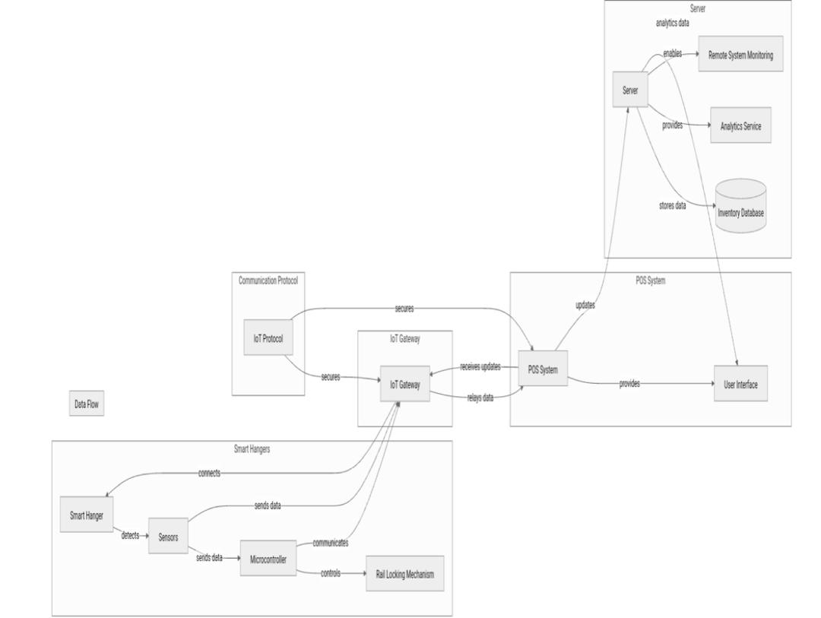

Figure 1 System architecture

1. Smart hangers: the hangers with rail locking mechanism, sensor and microcontroller. Hangers embedded with QR codes, microcontrollers, and IoT communication modules.
2. IoT gateways: Connects Hangers to the Internet and enables communication with the POS system, facilitating data exchange with the POS system.
3. POS system: This receives real time inventory updates from the smart hangers ensuring stock accuracy.
4. Server: stores inventory data while giving analytics and providing remote system monitoring. Stores historical inventory data and generates analytics for business decision-making.

**Components**

1. Sensors: detects removal and or replacement of clothing item.
2. Microcontroller: processes sensor data and controls the rail locking mechanisms while communicating with IoT gateway.
3. IoT Protocol: enables a secure communication between smart hangers and POS system
4. User interface: provides staff with real time inventory information and alerts.

***FLOW CHART DIAGRAM***

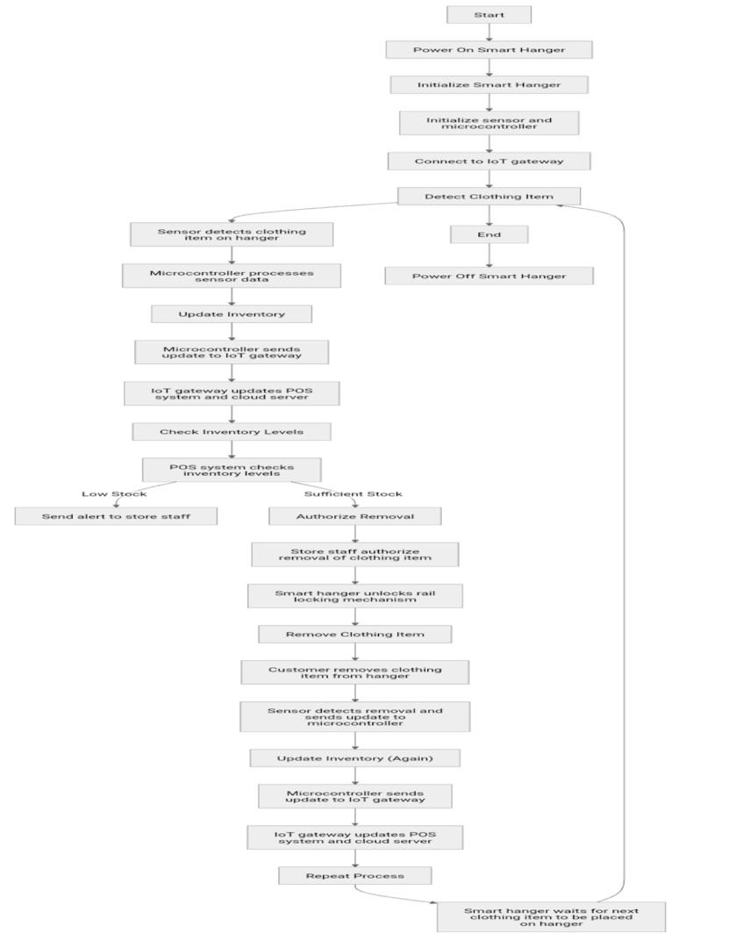

Figure 2 flow chart

Flow Chart

Start

1. Customer Removes/Replaces Clothing Item

- Sensor detects removal/replacement of clothing item

- Sensor sends signal to microcontroller

Process

2. Microcontroller Processes Sensor Data

- Microcontroller receives signal from sensor

- Microcontroller updates inventory data

3. Microcontroller Sends Data to IoT Gateway

- Microcontroller sends updated inventory data to IoT gateway

- IoT gateway receives data from microcontroller

4. IoT Gateway Sends Data to POS System

- IoT gateway sends updated inventory data to POS system

- POS system receives data from IoT gateway

5. POS System Updates Inventory

- POS system updates inventory levels based on received data

- POS system sends confirmation to IoT gateway

6. IoT Gateway Sends Confirmation to Microcontroller

- IoT gateway receives confirmation from POS system

- IoT gateway sends confirmation to microcontroller

Decision

7. Check Inventory Levels

- Microcontroller checks inventory levels

- If inventory levels are low, send alert to staff

8. Send Alert to Staff

- Microcontroller sends alert to staff via user interface

- Staff receives alert and takes action

End

9. System Updates and Monitors Inventory

- System continuously updates and monitors inventory levels

- System sends alerts and notifications as needed

This flow chart illustrates the main processes and decisions involved in the Smart Hanger System. It shows how the system updates inventory levels, sends alerts to staff, and monitors inventory levels in real-time.

Here's a more detailed explanation of each step:

1. Customer Removes/Replaces Clothing Item: The customer removes or replaces a clothing item from the smart hanger.

2. Sensor Detects Removal/Replacement: The sensor detects the removal or replacement of the clothing item and sends a signal to the microcontroller.

3. Microcontroller Processes Sensor Data: The microcontroller receives the signal from the sensor and updates the inventory data.

4. Microcontroller Sends Data to IoT Gateway: The microcontroller sends the updated inventory data to the IoT gateway.

5. IoT Gateway Sends Data to POS System: The IoT gateway sends the updated inventory data to the POS system.

6. POS System Updates Inventory: The POS system updates the inventory levels based on the received data and sends a confirmation to the IoT gateway.

7. IoT Gateway Sends Confirmation to Microcontroller: The IoT gateway receives the confirmation from the POS system and sends it to the microcontroller.

8. Check Inventory Levels: The microcontroller checks the inventory levels and sends an alert to the staff if the levels are low.

9. Send Alert to Staff: The microcontroller sends an alert to the staff via the user interface.

10. System Updates and Monitors Inventory: The system continuously updates and monitors the inventory levels, sending alerts and notifications as needed***.***

### Use case diagram

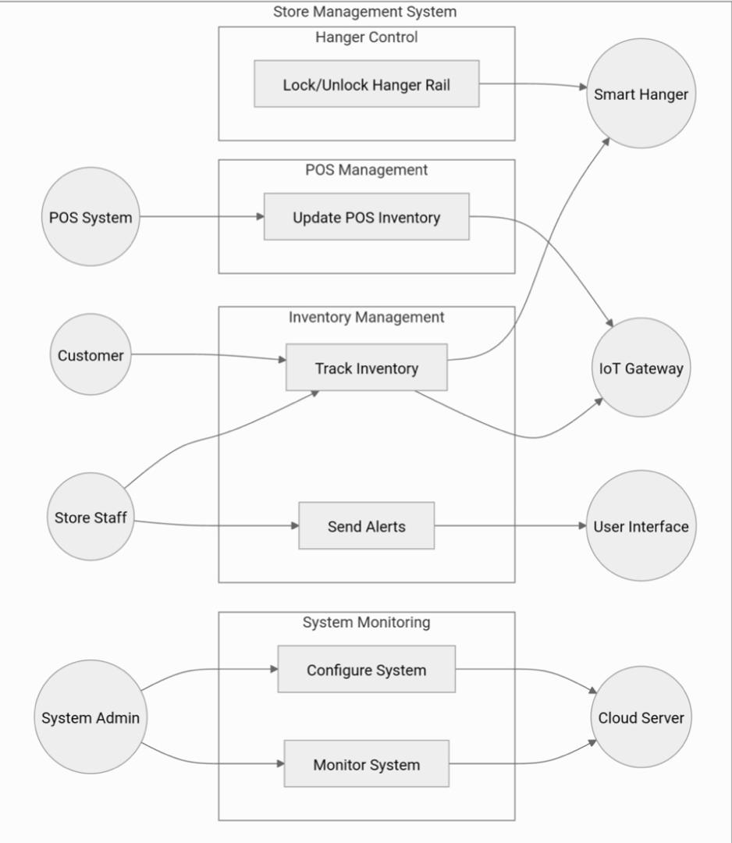

Figure 3 Use case diagram

Store Staff---> Track Inventory

Store Staff ----> Send Alerts

Customer ----> Track Inventory

POS System ----> Update POS Inventory

System Admin ----> Monitor System

System Admin ----> Configure System

Track Inventory --> Smart Hanger

Track Inventory --> IoT Gateway

Update POS Inventory --> IoT Gateway

Send Alerts--> User Interface

Monitor System --> Cloud Server

Configure System --> Cloud Server

Lock/Unlock Hanger Rail --> Smart Hanger

## 4.3 Use cases

1. Tracking inventory: automate real time inventory updates
2. Lock/unlock hanger rail: Prevent unauthorized removal of clothing items
3. Send alerts: notify staff of low stock or stock out.
4. Update POS inventory: Synchronize inventory data with POS System.
5. Monitor system: View analytics and system status through the server.
6. Configure system: Set up and maintain system.

## 4.4 Use case description

Store Staff - Performs: inventory tracking, send alerts

-Interacts: User interface

POS system - Performs: updates POS inventory

-Interacts: IoT Gateway

Customer - Triggers: Tracking of inventory

-Interacts: smart hanger (indirectly)

System Admin - Performs: monitors systems, configures systems.

-Interacts: server

### Data Flow Diagram

***Level 0***

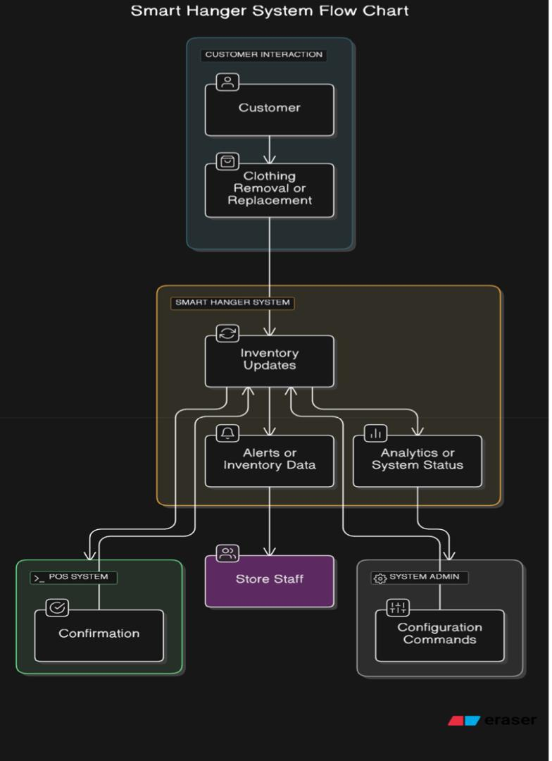

Figure 4 level 0 DFD

1. Customer → **Interacts with Smart Hanger** → Clothing Removal/Replacement

2. Smart Hanger System → **Sends Inventory Updates** → POS System

3. POS System → **Confirms Stock Updates** → Smart Hanger System

4. Smart Hanger System → **Notifies Store Staff** → Alerts on Inventory Status

5. System Admin → **Configures System & Reviews Analytics** → Cloud Server

**External entities**

1. Store staff: receives alerts and inventory updates
2. POS system: receives and confirms inventory updates
3. Customer: triggers inventory changes
4. Systems Admin: provides configuration settings and reviews analytics

**DATA FLOWS**

Customer → Clothing Removal/Replacement → Smart Hanger System.

Smart Hanger System → Inventory Updates → POS System.

POS System → Confirmation → Smart Hanger System.

Smart Hanger System → Alerts/Inventory Data → Store Staff.

System Admin → Configuration Commands → Smart Hanger System.

Smart Hanger System → Analytics/System Status → System Admin. Data flows

**Level 1**

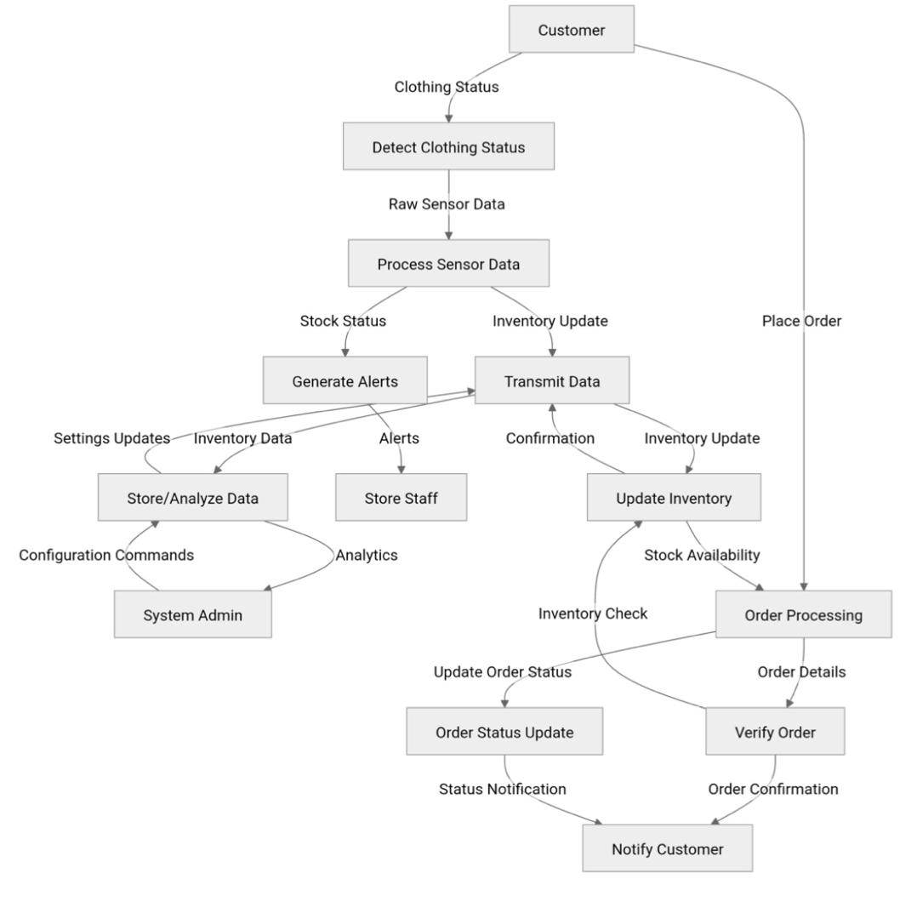

Figure 5 level 1 DFD

1. Sensors detect **clothing status** (present or removed).

2. Microcontroller processes sensor data and updates inventory status.

3. IoT gateway forwards data to **POS system and cloud server**.

4. POS system updates stock records and synchronizes sales data.

5. Store staff receives **alerts on stock levels**.

6. Cloud server analyzes data and generates business insights.

**PROCESSES**

1. Detects clothing status: sensors detects removal or replacement of clothes
2. Processes sensor data: microprocessor processes and sends updates
3. Data: IoT gateway forwards data to POS system and server.
4. Updates and Transmits inventory: POS system updates its records
5. & alerts: system notifies staff of stock issues.
6. Store/analyze data:

**DATA STORES**

1. Inventory databases: stores real time inventory in server.
2. Configure settings: stores systems settings in server.

**DATA FLOWS**

Customer → Clothing Status → Detect Clothing Status (Smart Hanger).

Detect Clothing Status → Raw Sensor Data → Process Sensor Data (Microcontroller).

Process Sensor Data → Inventory Update → Transmit Data (IoT Gateway).

Transmit Data → Inventory Update → Update Inventory (POS System).

Update Inventory → Confirmation → Transmit Data (IoT Gateway).

Transmit Data → Confirmation → Process Sensor Data (Smart Hanger).

Process Sensor Data → Stock Status → Generate Alerts.

Generate Alerts → Alerts → Store Staff.

Transmit Data → Inventory Data → Store/Analyze Data (Cloud Server).

Store/Analyze Data → Analytics → System Admin.

System Admin → Configuration Commands → Store/Analyze Data.

Store/Analyze Data → Settings Updates → Transmit Data.

FUTURE TRENDS IN SMART INVENTORY MANAGEMENT

1. AI Integration: Machine learning can predict demand patterns and optimize inventory stocking.

2. Block chain for Inventory Tracking: Secure and transparent inventory records.

3. Enhanced IoT Sensors: Improved accuracy in detecting stock movements.

4. Automation with Robotics: Smart robotic assistants for organizing and restocking shelves.

5. Augmented Reality (AR) for Retail: Enhancing customer experience through virtual product

## 4.5 Conclusion

The Smart Hanger System represents a revolutionary approach to inventory management, addressing the inefficiencies of traditional methods through IoT-driven automation. By ensuring real-time tracking, automated alerts, data analytics, and enhanced security, the system offers a scalable, efficient, and cost-effective solution for modern retail businesses.

Key Benefits

1. Improved Accuracy: Real-time tracking and automated updates minimize errors and ensure accurate inventory levels.

2. Increased Efficiency: Automated alerts and data analytics enable staff to focus on high-value tasks, improving overall productivity.

3. Enhanced Security: Secure communication protocols and access controls protect sensitive inventory data and prevent unauthorized access.

4. Scalability: The system's modular design and cloud-based infrastructure enable seamless scalability to meet growing business needs.

5. Cost Savings: Reduced manual labor, minimized stock outs, and optimized inventory levels result in significant cost savings.

Future Implications

The Smart Hanger System has far-reaching implications for the retail industry, enabling businesses to:

1. Stay Competitive: By adopting IoT-driven automation, retailers can differentiate themselves and stay ahead of competitors.

2. Improve Customer Experience: Real-time inventory tracking and automated alerts enable retailers to provide accurate product availability and reduce stock outs, enhancing customer satisfaction.

3. Drive Business Growth: By optimizing inventory management, retailers can increase sales, reduce waste, and improve overall business performance.

In conclusion, the Smart Hanger System offers a transformative solution for retail businesses, enabling them to streamline inventory management, improve efficiency, and drive growth in an increasingly competitive market.

# Chapter 5: System Implementation and Testing

## 5.1 Introduction

This chapter provides an exhaustive analysis of the implementation and validation of the Smart Hanger System, outlining the software and hardware integration methodologies employed. The system’s architecture is central around an ESP32 microcontroller, which interacts with a web-based platform to facilitate seamless user control over automated hangers. QR code technology is leveraged to enhance inventory management by enabling efficient product identification and retrieval. The Smart Hanger System is designed to streamline product tracking, enhance security, and optimize workflow efficiency through real-time interactions between the hardware and software components.

The ESP32 serves as the computational core, orchestrating bidirectional communication between hardware actuators and user interfaces via an embedded HTTP server. This architecture ensures real-time hanger status updates, remote actuation of locking mechanisms, and synchronization with an interactive web dashboard. The system is engineered with a focus on scalability, ensuring that the underlying architecture can accommodate future enhancements such as advanced authentication, predictive analytics, and AI-based inventory tracking. The chapter further explores testing paradigms, including unit tests for discrete system modules and integration tests to evaluate system-wide coherence and reliability. Emphasis is placed on ensuring high availability, low latency, and system robustness under varying operational conditions.

## User Interfaces

The Smart Hanger System incorporates multiple user-facing interfaces tailored to distinct operational roles, namely employees and till operators. Each interface has been meticulously designed to optimize workflow efficiency and usability while maintaining a user-friendly experience. These interfaces form the bridge between the digital control system and the physical hanger mechanisms.

**5.2.1 Login Page**

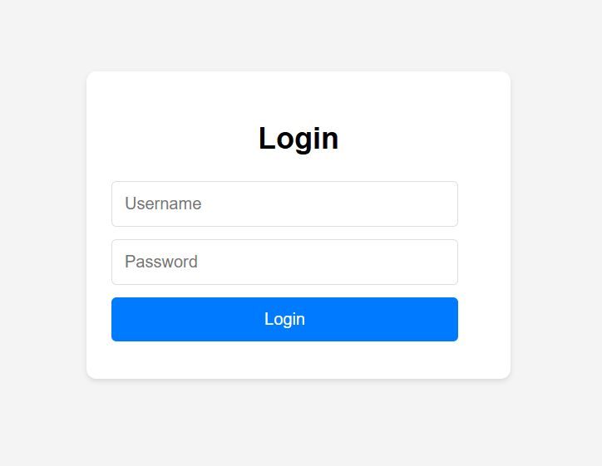

Figure 6 login page

* **Description:** Implements a role-based authentication mechanism to restrict access to system functionalities. Employees are directed to Smart_Hanger_System.html, while till operators are routed to QR2.html. The authentication module is structured to support future enhancements such as multi-factor authentication (MFA) and OAuth-based security integrations.
* **Key Features:**
  + Secure credential input fields with encrypted data transmission
  + Role-specific redirection logic ensuring correct access control
  + Input validation and access control for preventing unauthorized access
  + Scalability for additional authentication methods in future releases

### 5.2.2 Smart Hanger Employee Portal

Figure 7 smart hanger employee portal

* + 1. **Description:** This interface provides employees with control over hanger operations, including product assignment, hanger locking mechanisms, and inventory search functionality. The interface dynamically interacts with the ESP32 microcontroller to ensure real-time updates and precise hanger control.
* **Key Features:**
  + Fine-grained control of individual hangers with instant status feedback
  + Bulk assignment of products to a predefined range of hangers
  + Query-based product search system leveraging server-side filtering
  + Interactive visualization of hanger states with real-time UI updates
  + Remote actuation of servo-based hanger locks with secure API requests
  + Status indicators via LED control providing operational feedback
  + Future-proof design allowing easy integration with inventory databases

### 5.2.3 QR Code Generator

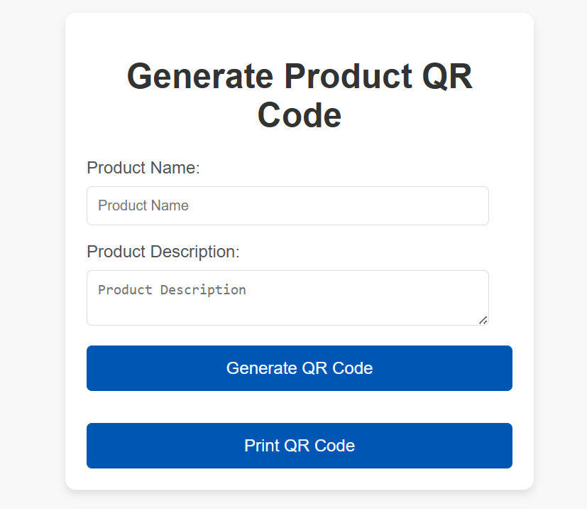

Figure 8 QR code generator

* **Description:** This module facilitates the automated generation of QR codes encoding product metadata, enabling efficient inventory tracking through a scannable interface. The QR codes integrate seamlessly with the till operator's workflow to facilitate real-time product verification and transaction processing.
* **Key Features:**
  + Dynamic encoding of product name, description, and SKU details
  + QR code rendering using qrcode.js with error correction capabilities
  + Real-time retrieval and display of scanned product data
  + Compatibility with mobile and desktop scanning solutions
  + Expandability for future enhancements, such as blockchain-based authentication

### 5.2.4 Point of Sale

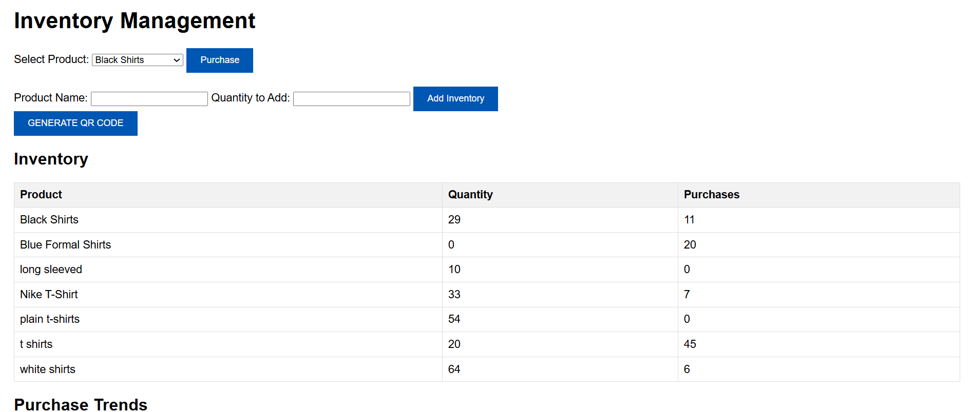

Figure 9 point of sale

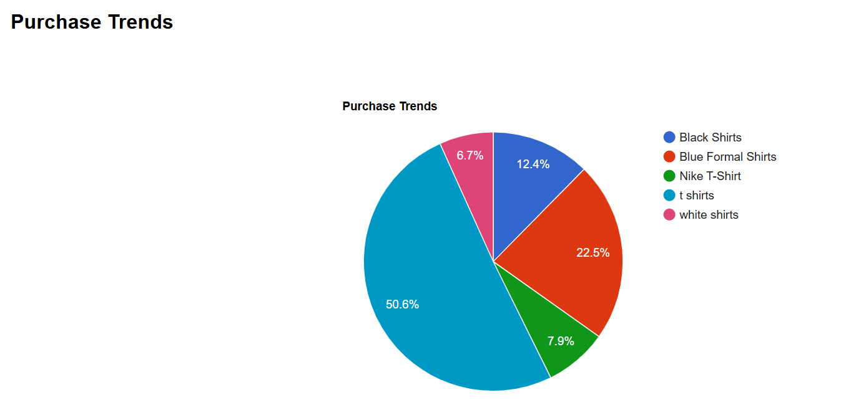

Figure 10 Purchase trends

## 5.3 Data Sources

The system's architecture relies on multiple data sources to ensure seamless operation and inter modular communication. These data sources include wireless communication protocols, embedded firmware logic, and external data integration for inventory validation.

1. **Wireless Communication Layer:**
   * Establishment of an HTTP server using Wifi.h and Webserver.h libraries.
   * Persistent network connection via predefined SSID and WPA security protocol.
   * Low-latency bidirectional communication between client interfaces and the ESP32.
   * Scalability for future wireless protocol integrations, such as BLE or LoRaWAN.
2. **Actuator Control Subsystem:**
   * Servo motors manipulated via ESP32Servo.h for precise control over hanger locking.
   * API endpoints (/lock, /unlock, /move) abstract hardware interactions.
   * Adaptive control logic ensuring precise and energy-efficient servo operation.
3. **Indicator Module:**
   * Dual LED control via /search, /stop, /red, and /green endpoints.
   * LED state encoding to convey hanger availability status.
   * Multi-state LED signalling to indicate different hanger conditions.
4. **QR Code Metadata Management:**
   * JSON-based encoding of product identifiers within scannable QR patterns.
   * Seamless integration with the till operator interface for inventory verification.
   * Future support for advanced cryptographic QR encoding to prevent counterfeiting.

## Business Logic

The Smart Hanger System’s operational logic is encapsulated in its firmware (Final Code.txt and Arduino code.txt), defining control workflows and user-system interactions. The business logic is designed to handle real-time operations with high efficiency while ensuring security and fault tolerance.

1. **User Interaction Protocols:**
   * Employees interact with hangers through authenticated commands.
   * Till operators leverage QR scanning for rapid inventory identification.
   * Future-proofed architecture to support predictive analytics for inventory trends.
2. **ESP32 API Infrastructure:**
   * The ESP32 web server processes HTTP requests via predefined RESTful endpoints.
   * Response payloads facilitate real-time UI updates and system monitoring.
   * Optimization strategies ensure minimal response latency for synchronous operations.
   * Security enhancements such as API token authentication planned for future updates.
3. **Hardware Interaction Framework:**
   * Servo mechanisms are actuated via command-based execution models.
   * LED signals provide dynamic user feedback regarding hanger status.
   * Exception handling mechanisms prevent mechanical misalignment or synchronization errors.
   * Modular design allowing additional hardware integrations such as RFID scanners.

## Unit Testing

Unit testing is essential to verify that individual components of the system function as expected. Below are some key unit tests for the ESP32-based smart hanger system:

**1. Servo Motor Control Test**

**Objective:** Ensure the servo motor moves to the correct positions.

**Test Cases:**

* Send a request to /move and verify the servo moves to moveAngle and returns to returnAngle.
* Send a request to /lock and verify the servo moves to lockAngle.
* Send a request to /unlock and verify the servo moves to unlockAngle.

**Code Snippet:**

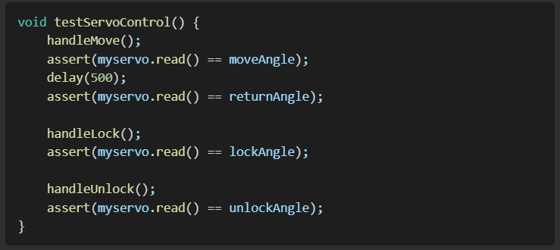

**2. LED Flashing Control Test**

**Objective:** Ensure the LED flashing behaviour operates correctly.

**Test Cases:**

* Send a request to /search and verify LEDs turn ON and OFF continuously.
* Send a request to /stop and verify LEDs turn OFF.

**Code Snippet:**

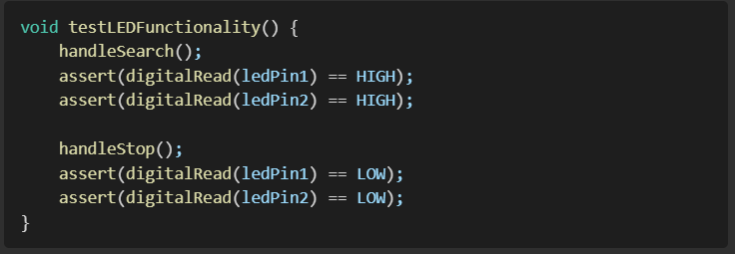

**3. Web Server Response Test**

**Objective:** Ensure the web server correctly handles requests.

**Test Cases:**

* Access /search and verify the response is LEDs flashing continuously!.
* Access /stop and verify the response is LEDs stopped flashing..
* Access an undefined route and verify the response is 404 Not Found.

**Code Snippet:**

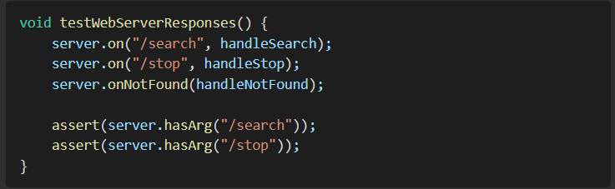

## 5.6 Integration Testing

Integration testing ensures that different modules of the system work together seamlessly.

**1. Web Interface to ESP32 Communication**

**Objective:** Validate communication between the web-based UI and the ESP32 server.

**Test Scenario:**

* Open Smart_Hanger_System.html in a web browser.
* Click "Search for Hanger".
* Observe if the ESP32 receives the /search request and LEDs flash.
* Click "Stop Flashing" and confirm LEDs stop.

**Code Snippet for integration testing:**

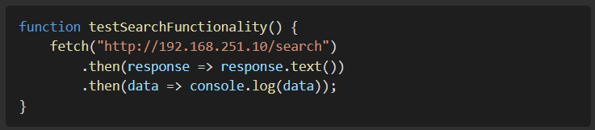

**2. Login and Access Control**

**Objective:** Verify the login system redirects users correctly based on their roles.

**Test Scenario:**

* Open login.html.
* Enter employee as the username and verify redirection to new.html.
* Enter till operator as the username and verify redirection to QR2.html.
* Enter an invalid username and verify an error alert appears.

**Code Snippet for login and access control:**

**3. QR Code Generation and Display**

**Objective:** Ensure QR codes are generated correctly based on user input.

**Test Scenario:**

* Open QR2.html.
* Enter product details and click "Generate QR Code".
* Verify a QR code appears.
* Scan the QR code with a mobile device and check if the product details are correctly displayed.

**Code Snippet for QR code generation and display:**

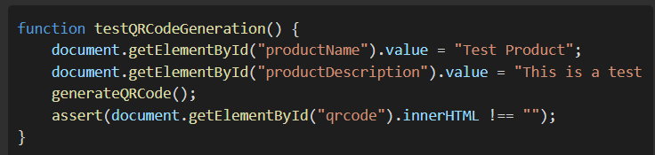

## 5.7 Conclusion

This chapter has systematically examined the implementation architecture and testing framework of the Smart Hanger System. By leveraging an ESP32 microcontroller, a structured API-based backend, and an interactive web-based UI, the system achieves real-time control over inventory hangers. Extensive unit and integration testing validated the system’s robustness, ensuring operational reliability across all components. The implementation demonstrates a scalable, secure, and efficient approach to hanger management within a retail context, providing an innovative convergence of embedded systems and web technologies.

Furthermore, the system has been designed with future adaptability in mind, allowing for seamless integration with predictive analytics, advanced security protocols, and next-generation inventory tracking technologies. This modularity ensures that the Smart Hanger System can continue evolving to meet the needs of an increasingly complex retail landscape.

# Chapter 6: Conclusion and Future Directions

## 6.0 Introduction

This chapter serves as the culmination of the Smart Hanger System project, providing a comprehensive overview of the project's achievements, challenges, and future potential. It revisits the initial objectives, assesses the technical implementation, offers recommendations for future development, and concludes with a reflection on the project's overall impact and significance. This chapter aims to provide a holistic perspective on the project's contributions to the field of retail technology and its potential to address the specific needs of retailers in developing economies like Zimbabwe.

## 6.1 Review of Objectives

The Smart Hanger System project was driven by a set of well-defined objectives aimed at revolutionizing retail operations. These objectives were:

* **Design a Smart Hanger System:** This objective was successfully achieved through the development of innovative hangers integrating rail-locking mechanisms and RGB light indicators.
* **Implement IoT Integration:** Seamless communication between the Smart Hanger System and a centralized inventory management platform was achieved using appropriate IoT communication protocols.
* **Develop Inventory Tracking Features:** The system successfully automated stock monitoring using RFID or barcode integration, minimizing human errors.
* **Create a Product Location System:** Customer convenience was enhanced by enabling easy product search and location assistance through a mobile web application and smart hanger-based product indicators.
* **Ensure Anti-Theft Functionality:** Security was significantly enhanced by implementing a POS-linked security mechanism and a tamper-detection system.
* **Design a User-Friendly Interface:** An intuitive mobile web application and an inventory dashboard for retail staff were developed to ensure efficient interaction with the system.
* **Test and Optimize the System:** Thorough usability testing and performance optimization were conducted to ensure system reliability, usability, and scalability.
* **Evaluate Cost and Feasibility:** A comprehensive cost assessment was conducted to ensure the Smart Hanger System is financially viable and practical for implementation by small and medium retailers.

The project successfully met these objectives, demonstrating the viability of a comprehensive, IoT-based solution for retail inventory management and security.

## 6.2 Technical Review

The Smart Hanger System's technical architecture is based on the effective integration of several key components:

* **ESP32 Microcontroller:** This component serves as the system's computational core, facilitating bidirectional communication between hardware actuators and user interfaces.
* **Sensors:** These components detect the presence and removal of clothing items, enabling real-time inventory tracking.
* **Locking Mechanism:** This automated security feature prevents unauthorized removal of clothing items.
* **Communication Protocols:** Standardized protocols such as HTTPS and HTTP ensure seamless communication between the smart hangers and the POS system.
* **User Interfaces:** These intuitive interfaces provide retail staff with real-time inventory information and enable efficient system management.
* **Data Sources and Storage:** Utilization of JSON-based encoding of product identifiers within scannable QR patterns for efficient tracking with seamless integration to POS.
* **Robust Firmware Implementation:** Command based hardware interaction that optimizes the servo mechanism.

The system's success relies on the interaction between hardware and software, ensuring that the system is scalable, safe, and reliable.  
The unit and integration tests conducted show the viability of the solution, proving the reliability and practicality of the implementation.

## 6.3 Recommendations

Based on the findings and experiences of this project, the following recommendations are provided:

* **Further Enhance POS Integration:** Streamline the integration with a wider range of POS systems, including cloud-based platforms, to ensure seamless operation across different retail environments.
* **Implement Advanced Security Measures:** Enhance the system's security with multi-factor authentication, end-to-end encryption, and real-time threat detection to protect against evolving cyber threats.
* **Optimize Power Efficiency:** Further optimize the power consumption of the smart hangers by exploring energy-harvesting technologies and adaptive power management algorithms.
* **Develop a Comprehensive Training Program:** Create a comprehensive training program for retail staff to ensure they can effectively use and maintain the Smart Hanger System.
* **Consider Cloud Hosting Solutions.** Scalability and reliability increased with the use of AWS/Google cloud platforms as a storage soultion
* **Conduct Pilots with Small-Sized Retail Stores** Assess the potential to scale to larger scale clients.
* **Implement alternative energy sources for the hangers.** Solar, kinetic, inductive charging to prevent manual charging.

These recommendations can help to ensure that the Smart Hanger System continues to evolve and meet the changing needs of the retail industry.

## 6.4 Conclusion

The Smart Hanger System represents a significant step forward in addressing the persistent challenges of inventory management, security, and customer experience within the retail sector, particularly in the context of Zimbabwe's developing economy. This project successfully integrated IoT technology, secure locking mechanisms, and real-time data analytics to create a comprehensive solution that automates stock tracking, prevents theft, and enhances the overall shopping journey.

Through rigorous analysis of existing literature, careful system design, and diligent implementation, the Smart Hanger System offers a tangible improvement over traditional manual inventory methods. By providing real-time stock updates, the system empowers retailers to minimize stockouts, reduce overstocking, and optimize resource allocation. The anti-theft functionality, with its rail-locking mechanism and tamper detection, addresses the critical issue of inventory shrinkage, protecting retailers from significant financial losses. Moreover, the system's user-friendly interface, coupled with features like product location assistance, significantly enhances customer satisfaction and streamlines the shopping experience.

The adoption of an Agile development methodology and the effective use of CASE tools facilitated a structured and efficient development process. This iterative approach allowed for continuous feedback and refinement, ensuring that the final system aligns with the specific needs and challenges of Zimbabwean retailers. The questionnaires and forms utilized in the research phase provided valuable insights from both retail staff and customers, contributing to the practical relevance and user-centric design of the Smart Hanger System. The successful implementation of the system, detailed in Chapter 5, showcases the feasibility and potential of IoT-based solutions to revolutionize retail operations. The unit and integration testing performed demonstrate the system's reliability and functionality.

## 6.5 Project Aims Revisited

This project has effectively addressed its primary aims:

* **Enhanced Inventory Management:** The integration of RFID or barcode technology enables real-time stock tracking and automated synchronization, eliminating discrepancies and reducing the risk of stockouts or overstocking.
* **Strengthened Retail Security:** The rail-locking mechanism and tamper-detection system provide a robust layer of security, preventing unauthorized removal of clothing items and minimizing theft.
* **Improved Customer Shopping Experience:** The RGB light indicators and mobile web application empower customers to easily locate items and determine stock availability, reducing frustration and enhancing convenience.
* **Optimized Retail Operations:** The automation of stock monitoring reduces the need for labour-intensive processes, freeing up staff to focus on customer service and sales.
* **Developed a Scalable and Cost-Effective Solution:** The utilization of cost-effective materials and IoT components, combined with easy installation and maintenance, ensures the system is accessible to retailers of different sizes.
* **Ensured Ethical and Sustainable Implementation:** The project addressed data privacy, accessibility, and environmental impact, demonstrating a commitment to responsible technology implementation.
* **Conducted Thorough Testing and Optimization:** Rigorous testing in simulated and real-world environments has validated the system's functionality and performance.

## 6.6 Challenges and Lessons Learned

While the project has achieved its primary objectives, several challenges were encountered during the development process. These included:

* **Integration Complexity:** Integrating the Smart Hanger System with existing POS systems required careful planning and execution to ensure seamless data flow and minimal disruption to existing operations.
* **Connectivity Issues:** Ensuring reliable wireless connectivity in diverse retail environments presented a challenge, requiring the selection of appropriate communication protocols and robust network infrastructure.
* **Data Security Concerns:** Protecting customer and inventory data required the implementation of robust security measures, including encryption and access control mechanisms.
* **Power Management:** Optimizing the power consumption of the IoT-enabled hangers to ensure long battery life presented a technical challenge.

These challenges provided valuable lessons learned, emphasizing the importance of thorough planning, robust testing, and a focus on security and scalability in IoT-based retail solutions.

## 6.7 Future Directions

Building on the success of the Smart Hanger System, several avenues for future research and development can be explored:

* **AI-Powered Predictive Analytics:** Integrating machine learning algorithms to predict demand patterns and optimize inventory stocking, further enhancing efficiency and reducing waste.
* **Blockchain Integration:** Utilizing blockchain technology to create a secure and transparent ledger for tracking inventory, ensuring data integrity and preventing counterfeiting.
* **Enhanced Sensor Technology:** Incorporating advanced sensor technologies, such as computer vision, to provide more detailed information about customer interactions with products.
* **Robotics Automation:** Integrating robotic systems to automate restocking and organization tasks, further reducing labor costs and improving efficiency.
* **Personalized Customer Experiences:** Leveraging data analytics to provide personalized product recommendations and promotions, enhancing customer engagement and driving sales.
* **Expansion to Other Retail Sectors:** Adapting the Smart Hanger System for use in other retail sectors, such as grocery stores and pharmacies.
* **Integration with Supply Chain Management:** Extending the system to track products throughout the supply chain, providing end-to-end visibility and improving efficiency.
* **Explore alternative energy sources for the hangers.** Solar, kinetic, inductive charging to prevent manual charging.

## 6.8 Final Reflections

The Smart Hanger System represents a practical and innovative solution to the challenges facing Zimbabwean retailers. By combining IoT technology, security mechanisms, and user-centric design, this project offers a pathway towards greater efficiency, profitability, and customer satisfaction. This project demonstrates the potential of technology to transform the retail landscape and contribute to economic growth in developing economies. Continued research and development in this area will undoubtedly lead to even more sophisticated and effective solutions that empower retailers to thrive in an increasingly competitive market. Ultimately, this project provides a valuable foundation for future endeavours aimed at revolutionizing the retail industry through smart, connected technologies.

# Refrences :

* possibolt.com
* Barcode.com
* Outdoor Industry Association
* Digimarc Corporation
* Ditto Sustainable Brand Solutions
* Kwon & Park (2018)
* Gabriel Miguel T.
* Pantano & Timmermans (2014)

# Appendix

## Questionnaire

### Questionnaire for Retail Staff

This questionnaire aims to gather your insights and expectations regarding a potential Smart Hanger System and its possible impact on your work.

**Demographics (Optional):**

1. Store Department:

* ___________

1. Years of Experience in Retail:

* ___________

**Current Inventory Management Challenges:**

1. How often do you encounter difficulties with current inventory management processes?

* ( ) Very Frequently
* ( ) Frequently
* ( ) Occasionally
* ( ) Rarely
* ( ) Never

1. How satisfied are you with the current efficiency of stocktaking?

* ( ) Very Satisfied
* ( ) Satisfied
* ( ) Neutral
* ( ) Dissatisfied
* ( ) Very Dissatisfied

1. How much time do you estimate is spent on stocktaking per week?

* ___________ hours

1. How often do you find it challenging to locate specific products for customers?

* ( ) Very Frequently
* ( ) Frequently
* ( ) Occasionally
* ( ) Rarely
* ( ) Never

1. To what extent does theft or loss impact your department/store?

* ( ) Significantly
* ( ) Moderately
* ( ) Slightly
* ( ) Not at all

**Expectations for the Smart Hanger System:**

1. How helpful do you think real-time stock updates would be in improving inventory management?

* ( ) Very Helpful
* ( ) Helpful
* ( ) Neutral
* ( ) Not Very Helpful
* ( ) Not Helpful at All

1. How much do you think a system with RGB light indicators would improve product location efficiency?

* ( ) Significantly
* ( ) Moderately
* ( ) Slightly
* ( ) Not at all

1. How effective do you anticipate an anti-theft feature on the hangers would be?

* ( ) Very Effective
* ( ) Effective
* ( ) Neutral
* ( ) Not Very Effective
* ( ) Not Effective at All

1. How important is a user-friendly interface for a new inventory management system?

* ( ) Very Important
* ( ) Important
* ( ) Neutral
* ( ) Not Very Important
* ( ) Not Important at All

**System Feature Priorities:**

1. Which features of a Smart Hanger System do you think would be most useful for your daily tasks? (Select up to three)

* ( ) Real-time stock updates
* ( ) Anti-theft alerts
* ( ) Product location using RGB lights
* ( ) Automated stocktaking
* ( ) User-friendly interface
* ( ) Data analytics on sales trends

**Questionnaire for Customers**

This questionnaire aims to gather your feedback on your shopping experience and how a Smart Hanger System could potentially improve it.

**Demographics (Optional):**

1. Age Group:

* ( ) Under 18
* ( ) 18-25
* ( ) 26-35
* ( ) 36-50
* ( ) Over 50

1. Gender:

* ( ) Male
* ( ) Female
* ( ) Other

**Current Shopping Experience:**

1. How satisfied are you with the current availability of products in this store?

* ( ) Very Satisfied
* ( ) Satisfied
* ( ) Neutral
* ( ) Dissatisfied
* ( ) Very Dissatisfied

1. How often do you have difficulty finding specific sizes or items?

* ( ) Very Frequently
* ( ) Frequently
* ( ) Occasionally
* ( ) Rarely
* ( ) Never

1. How important is it to you to know if an item is in stock before trying to find it?

* ( ) Very Important
* ( ) Important
* ( ) Neutral
* ( ) Not Very Important
* ( ) Not Important at All

**Suggestions for Improvement:**

1. What aspects of your shopping experience could be improved?

* ___________

1. What features in a Smart Hanger System would you find most beneficial?

* ___________

1. Do you have any other comments or suggestions regarding how technology could enhance your shopping experience in this store?

* ___________

These revised questionnaires aim to gather valuable input before the Smart Hanger System is implemented, focusing on current challenges, expectations, and priorities for improvement.

## Forms

**Smart Hanger System - Assessment Form**

**Date:** _________________________

**Time:** _________________________

**Location (Store/Department):** _________________________

**Role (Staff/Customer/Manager):** _________________________

1. **Current Inventory Management and Shopping Experience**

### A. For Retail Staff/Managers:

1. **Inventory Tracking Methods:**

* Describe the current methods used for inventory tracking in your store/department:

1. **Frequency of Stocktaking:**

* How often is physical stocktaking conducted?
* ( ) Daily
* ( ) Weekly
* ( ) Monthly
* ( ) Quarterly
* ( ) Other: _________________________

1. **Challenges with Stocktaking:**

* What are the main challenges encountered during stocktaking? (Check all that apply)
* ( ) Time-consuming process
* ( ) Inaccurate counts
* ( ) Labor-intensive
* ( ) Disruption to sales
* ( ) Other: _________________________

1. **Inventory Discrepancies:**

* How often do discrepancies occur between recorded and actual stock levels?
* ( ) Very Frequently
* ( ) Frequently
* ( ) Occasionally
* ( ) Rarely
* ( ) Never

1. **Time Spent on Inventory Management:**

* Approximately how many staff hours per week are dedicated to inventory management tasks?
* _________________________ hours

1. **Current Security Measures:**

* Describe the current security measures in place to prevent theft:

### B. For Customers:

1. **Product Availability Satisfaction:**

* How satisfied are you with the availability of products in this store?
* ( ) Very Satisfied
* ( ) Satisfied
* ( ) Neutral
* ( ) Dissatisfied
* ( ) Very Dissatisfied

1. **Difficulty Finding Items:**

* How often do you experience difficulty in finding specific items (sizes, colors, etc.)?
* ( ) Very Frequently
* ( ) Frequently
* ( ) Occasionally
* ( ) Rarely
* ( ) Never

1. **Importance of Stock Information:**

* How important is it to you to know if an item is in stock before locating it in the store?
* ( ) Very Important
* ( ) Important
* ( ) Neutral
* ( ) Not Very Important

**II. Expectations and Perceived Benefits of a Smart Hanger System**

**A. For Retail Staff/Managers:**

1. **Potential Benefits:**

* What potential benefits do you see in implementing a Smart Hanger System? (Check all that apply)
* ( ) Improved inventory accuracy
* ( ) Reduced stocktaking time
* ( ) Enhanced product location
* ( ) Theft prevention
* ( ) Better data analytics
* ( ) Improved staff efficiency
* ( ) Other: _________________________

1. **Feature Priorities:**

* Which features of a Smart Hanger System would be most valuable for improving store operations? (Rank the top 3 in order of importance, 1 being the most important)
* ____ Real-time stock updates
* ____ Anti-theft alerts
* ____ Product location using RGB lights
* ____ Automated stocktaking
* ____ User-friendly staff interface
* ____ Data analytics on sales trends

1. **Concerns about Implementation:**

* What are your main concerns regarding the implementation of a Smart Hanger System?

1. **Integration with POS System:**

* How important is seamless integration with the existing POS system?
* ( ) Very Important
* ( ) Important
* ( ) Neutral
* ( ) Not Very Important
* ( ) Not Important at All

**B. For Customers:**

1. **Potential Benefits:**

* What potential benefits do you see in a Smart Hanger System for your shopping experience? (Check all that apply)
* ( ) Easier product location
* ( ) Real-time stock information
* ( ) Faster shopping
* ( ) Improved staff assistance
* ( ) Other: _________________________

1. **Feature Preferences:**

* Which features of a Smart Hanger System would most enhance your shopping experience? (Rank the top 2 in order of importance, 1 being the most important)
* ____ Ability to locate items easily
* ____ Access to real-time stock information
* ____ Faster checkout process

1. **Use of Technology in Retail:**

* How comfortable are you with using technology (e.g., mobile apps, interactive displays) while shopping?
* ( ) Very Comfortable
* ( ) Comfortable
* ( ) Neutral
* ( ) Uncomfortable
* ( ) Very Uncomfortable

**III. Additional Feedback**

1. **Suggestions for Improvement:**

* Do you have any suggestions for how a Smart Hanger System could be designed to best meet your needs or improve the retail environment?

This form is designed to gather comprehensive feedback before the implementation of a Smart Hanger System. It aims to understand current challenges, expectations, and priorities from both staff and customer perspectives.